 

|  |  |
| --- | --- |
|  |  |

Data Compliance Test (DCT)

Test Cases for

Obstetrics Record

*<HCP Name>*

Table of Contents

1 Testing Instructions to HCPs 3

1.1 Self-Service Testing Phase 3

1.2 Final Testing Phase 3

1.3 Preparation of DCT Test Report 4

2 Test Case Details 5

OBS-LV3-001 [FOR LEVEL 3 DATA UPLOAD ONLY] 5

OBS-LV3-002 [FOR LEVEL 3 DATA UPLOAD ONLY] 18

OBS-LV2-001 [FOR LEVEL 2 DATA UPLOAD ONLY] 30

OBS-LV2-002 [FOR LEVEL 2 DATA UPLOAD ONLY] 40

OBS-LV1-001 [FOR LEVEL 1 DATA UPLOAD ONLY] 49

OBS-LV1-002 [FOR LEVEL 1 DATA UPLOAD ONLY] 56

3 Appendix – Sample Messages 67

4 Appendix – Testing HCP and HCRs Information 73

5 Appendix – Sample Results in eHR Viewer (EVE) 74

6 Appendix – Actual Data Values (Sample) 78

# Testing Instructions to HCPs

## Self-Service Testing Phase

* After development of the data upload programmes, you can use the **Self-Service test accounts and test HCRs** provided by eHealth for connection to the eHealth testing environment and proceed with the self-service testing.
* You can proceed with the Self-service test at your own pace by following this Self-Service Testing Guide and using the test cases provided in section 2.
* You can verify the **correctness** and **completeness** of the data upload by:
  + checking the interface files / messages generated in your system against the sample expected results of interface files /messages for all test cases as provided;
  + checking the results on eHR Viewer (EVE) by logging into the testing eHealth with the provided test account; and
  + checking the upload status through Process Summary and Exception Report in eHR Inbox by logging into the testing eHealth.
* For data fields requiring eHR Codex values, you can refer the Code Sets provided with the Self-Service Kit.
* For details of technical requirements of the data interface files, please refer to the ‘Developer Quick Guide for Obstetrics Record Upload to eHealth.docx’.
* You are required to perform the test cases that are relevant to the data compliance level (Level 1, 2 or 3) supported by your clinic.
* You are required to perform the first batch of data upload by **Data Materialization** (**DM**) mode. **DM mode** is denoted in the interface by a fixed value **BL-M** in *HL7 OBX.4*
* You should use **Incremental Load** (**INC**) mode for the second batch of data upload to update the previously uploaded records. **INC mode** is denoted in the interface by a fixed value **BL** in *HL7 OBX.4.*
* Since the **DM** mode would replace the corresponding records previously uploaded to eHealth, you may repeat your testing unlimited number of times by uploading the first batch by **DM** mode.
* It should be noted that an obstetric record will contain multiple obstetric record types. The data field “Record Key” should be unique for the obstetric record types ‘Antenatal initial assessment’ and ‘Obstetric report’. Since the obstetric record types ‘Delivery record’, ‘Obstetric progress’ and ‘Obstetric ultrasound’ support multiple ‘Baby information’ and ‘Foetal’ records respectively, same “Record Key” can be used in corresponding obstetric record types.
* When all required test cases can be completed smoothly and correctly in this phase, you can proceed to the Final Testing Phase and submit **production environment setup form** to eHR DCT Support for preparation.

## Final Testing Phase

* You can start the Final Testing Phase once all test cases in the Self-Service Testing phase are passed.
* You should start Final Test by executing the test cases provided in section 2 with **Final Testing HCRs** provided by eHR DCT Support.
* You can verify the **correctness** and **completeness** of testing results by checking results in eHR Viewer (EVE) and the upload status through Process Summary, Exception Report and Regrade Report in eHR Inbox.
* For Obstetrics Record DCT test cases, there are **TWO** batches of data files / transactions to be uploaded to the testing eHealth. The required records must be correctly uploaded from these 2 consecutive batches respectively.
* The Final Test will be considered PASSED if all the following criteria are met:
  + The TWO batches of test data files are uploaded consecutively in the correct sequence. The second batch of data files/transactions must be submitted after completion of processing of the first batch by eHealth.
  + No additional data files / transactions are uploaded in between or after the uploads of the above two batches of data files / transactions to amend any records.
  + No exception records are reported from the uploads.
  + No manual interventions have been made to the data files / transactions.
* If the Final Test failed, you can re-attempt the Self-Service Test and Final Test until a successful run can be completed.

## Preparation of DCT Test Report

* Once you have successfully passed the Final Test based on the above criteria, you should complete this document by attaching the below items to this document at the appropriate space provided:
  + Actual data files uploaded
  + Screen-shot of each test case
* You are required to submit this completed ‘DCT Test Cases’ document to eHR DCT Support for further processing. eHR DCT Support will provide feedback **within 10 working days**.

# Test Case Details

* + *OBS-LV3-001 and OBS-LV3-002 : Only applicable for testing level 3 data upload*
  + *OBS-LV2-001 and OBS-LV2-002 : Only applicable for testing level 2 data upload*
  + *OBS-LV1-001 and OBS-LV1-002 : Only applicable for testing level 1 data upload*
  + *Please complete and collect the upload results for OBS-xxx-001 before proceeding to OBS-xxx-002.*

| **1** | **Test Case ID** | OBS-LV3-001 [FOR LEVEL 3 DATA UPLOAD ONLY] | |
| --- | --- | --- | --- |
|  | **Function Description** | HCP has received the sharing consents from testing HCRs, then perform first data upload of HCRs’ clinical records to eHealth by DM Mode for level 3 data. | |
| **Subsequent case of** | N/A | |
| **Testing Assumption** | * HCR1-HCR8 have already given sharing consents to the HCP. * The EMR system (EMRS) will upload Batch 1 data files to eHealth with all obstetrics records of <HCR1> - <HCR8> created by DM mode. | |
| **Test Actions** | HCP creates below obstetrics records in EMR system: | |
| 1a | **Case scenario**: Input new Delivery record with *valid* code set for <HCR1> in EMRS as follows:   * Obstetric record type code = “DELIV_HK” * Delivery date = “1-Apr-2023“ * Delivery or abortion hospital local description = [source system provided] * Gestation (week) = 40 * Gestation (day) = 1 * Birth order = 1 * Baby birth datetime = “1-Apr-2023 09:40:00” * Sex of baby local description = “F” * Mode of delivery local description = ”NSD” * Birth outcome local description = “LIVE” * Baby birth weight (gm) = 3060 * Baby breastfeeding on discharge local description = “Yes”   == Actual data values (Refer to “Appendix - Actual Data Values (Sample)” for details)  Expected data contents for Level 3 interface record:   * Obstetric record type code = “DELIV_HK” * Delivery date = “1-Apr-2023“ * Delivery or abortion hospital code = [source system provided] * Delivery or abortion hospital description = [source system provided] * Delivery or abortion hospital local description = [source system provided] * Gestation (week) = 40 * Gestation (day) = 1 * Birth order = 1 * Baby birth datetime = “1-Apr-2023 09:40:00” * Sex of baby code = “F” * Sex of baby description = “Female” * Sex of baby local description = “F” * Mode of delivery code = “NSD” * Mode of delivery description = “Normal spontaneous delivery” * Mode of delivery local description = ”NSD” * Birth outcome code =”LB” * Birth outcome description = “Livebirth” * Birth outcome local description = “LIVE” * Baby birth weight (gm) = 3060 * Baby breastfeeding on discharge code = “Y” * Baby breastfeeding on discharge description = “Yes” * Baby breastfeeding on discharge local description = “Yes” |
| 1b | **Case scenario**: Input new Delivery record with *invalid* code set for <HCR2> in EMRS as follows:   * Obstetric record type code = “DELIV_HK” * Delivery date = “15-Apr-2024“ * Delivery or abortion hospital local description = [source system provided] * Gestation (week) = 38 * Gestation (day) = 2 * Birth order = 1 * Baby birth datetime = “15-Apr-2024 15:20:00” * Sex of baby local description = “M” * Mode of delivery local description = ”Elective LSCS” * Birth outcome local description = “Live-Birth” * Baby birth weight (gm) = 3540 * Baby breastfeeding on discharge local description = “Yes”   == Actual data values (Refer to “Appendix - Actual Data Values (Sample)” for details)  Expected data contents for Level 3 interface record:   * Obstetric record type code = “DELIV_HK” * Delivery date = “15-Apr-2024“ * Delivery or abortion hospital code = [source system provided] * Delivery or abortion hospital description = [source system provided] * Delivery or abortion hospital local description = [source system provided] * Gestation (week) = 38 * Gestation (day) = 2 * Birth order = 1 * Baby birth datetime = “15-Apr-2024 15:20:00” * Sex of baby code = “M” * Sex of baby description = “Male” * Sex of baby local description = “M” * Mode of delivery code = “CS” * Mode of delivery description = “Caesarean section” * Mode of delivery local description = ”Elective LSCS” * Birth outcome code =”LB” * Birth outcome description = “Live-Birth” * Birth outcome local description = “Live-Birth” * Baby birth weight (gm) = 3540 * Baby breastfeeding on discharge code = “Y” * Baby breastfeeding on discharge description = “Yes” * Baby breastfeeding on discharge local description = “Yes”   *Remark: Record will show in “Re-grade Report” as Birth outcome description not matched the eHR description of Birth outcome code in IAMS.* |
| 1c | **Case scenario:** Input new Antenatal initial assessment record with *valid* code set for <HCR3> in EMRS as follows:   * Obstetric record type code = “ASSESSMENT” * Antenatal initial assessment date = “30-Oct-2023” * Expected date of confinement = “12-Jun-2024“ * Last menstrual period = “05-Sep-23” * Menstrual cycle length (day) = 32 * Gravida = 1 * Parity = 0 * Systolic blood pressure (mmHg) - antenatal initial assessment = 112 * Diastolic blood pressure (mmHg) - antenatal initial assessment = 68 * Pulse (/min) - antenatal initial assessment = 75 * Height (cm) = 158 * Pre-pregnant weight (kg) = 49 * Body mass index = 19.6   == Actual data values (Refer to “Appendix - Actual Data Values (Sample)” for details)  Expected data contents for Level 3 interface record:   * Obstetric record type code = “ASSESSMENT” * Antenatal initial assessment date = “30-Oct-2023” * Expected date of confinement = “12-Jun-2024“ * Last menstrual period = “05-Sep-23” * Menstrual cycle length (day) = 32 * Gravida = 1 * Parity = 0 * Systolic blood pressure (mmHg) - antenatal initial assessment = 112 * Diastolic blood pressure (mmHg) - antenatal initial assessment = 68 * Pulse (/min) - antenatal initial assessment = 75 * Height (cm) = 158 * Pre-pregnant weight (kg) = 49 * Body mass index = 19.6 |
| 1d | **Case scenario:** Input new Antenatal initial assessment record with *valid* code set for <HCR4> in EMRS as follows:   * Obstetric record type code = “ASSESSMENT” * Antenatal initial assessment date = “16-Nov-2023“ * Expected date of confinement = “11-Jul-2024 “ * Last menstrual period = “05-Oct-23” * Menstrual cycle length (day) = 30 * Gravida = 2 * Parity = 1 * Height (cm) = 158 * Pre-pregnant weight (kg) = 51 * First visit weight (kg) = 52 * Body mass index = 20.5   == Actual data values (Refer to “Appendix - Actual Data Values (Sample)” for details)  Expected data contents for Level 3 interface record:   * Obstetric record type code = “ASSESSMENT” * Antenatal initial assessment date = “16-Nov-2023“ * Expected date of confinement = “11-Jul-2024 “ * Last menstrual period = “05-Oct-23” * Menstrual cycle length (day) = 30 * Gravida = 2 * Parity = 1 * Height (cm) = 158 * Pre-pregnant weight (kg) = 51 * First visit weight (kg) = 52 * Body mass index = 20.5 |
| 1e | **Case scenario:** Input new Obstetric Progress record with *valid* code set for <HCR5> in EMRS as follows:   * Obstetric record type code = “PROGRESS” * Progress date = “02-Apr-2024” * Expected date of confinement at progress date = “09-Jul-2024” * Gestational age at progress date (week) = 26 * Gestational age at progress date (day) = 0 * Body weight (kg) = 62 * Symphysial fundal height (cm) = 24 * Systolic blood pressure (mmHg) = 108 * Diastolic blood pressure (mmHg) = 71 * Pulse (/min) = 111 * Urine albumin local description = “-ve” * Urine sugar local description = “-ve” * Foetal order = 1 * Foetal presentation local description = “Cephalic” * Foetal engagement local description = “Above brim” * Foetal heart sound local description = “Heard” * Foetal movement local description = “Active”   == Actual data values (Refer to “Appendix - Actual Data Values (Sample)” for details)  Expected data contents for Level 3 interface record:   * Obstetric record type code = “PROGRESS” * Progress date = “02-Apr-2024” * Expected date of confinement at progress date = “09-Jul-2024” * Gestational age at progress date (week) = 26 * Gestational age at progress date (day) = 0 * Body weight (kg) = 62 * Symphysial fundal height (cm) = 24 * Systolic blood pressure (mmHg) = 108 * Diastolic blood pressure (mmHg) = 71 * Pulse (/min) = 111 * Urine albumin code = “-ve” * Urine albumin description = “Negative” * Urine albumin local description = “-ve” * Urine sugar code = “-ve” * Urine sugar description = “Negative” * Urine sugar local description = “-ve” * Foetal order = 1 * Foetal presentation code = “CEPH” * Foetal presentation description = “Cephalic” * Foetal presentation local description = “Cephalic” * Foetal engagement code = “5/5” * Foetal engagement description = “Above brim” * Foetal engagement local description = “Above brim” * Foetal heart sound code = “H” * Foetal heart sound description = “Heard” * Foetal heart sound local description = “Heard” * Foetal movement code = “ACT” * Foetal movement description = “Active foetal movement” * Foetal movement local description = “Active” |
|  | 1f | **Case scenario:** Input new Obstetric Progress record with *invalid* code set for <HCR6> in EMRS as follows:   * Obstetric record type code = “PROGRESS” * Progress date = “23-Oct-2023” * Expected date of confinement at progress date = “20-Nov-2023” * Gestational age at progress date (week) = 36 * Gestational age at progress date (day) = 0 * Body weight (kg) = 70.5 * Symphysial fundal height (cm) = 36 * Systolic blood pressure (mmHg) =112 * Diastolic blood pressure (mmHg) = 64 * Pulse (/min) = 98 * Urine albumin local description = “-ve” * Urine sugar local description = “-ve” * Foetal order = 1 * Foetal presentation local description = “Cephalic” * Foetal engagement local description = “Above-Brim” * Foetal heart sound local description = “Heard” * Foetal movement local description = “Active”   == Actual data values (Refer to “Appendix - Actual Data Values (Sample)” for details)  Expected data contents for Level 3 interface record:   * Obstetric record type code = “PROGRESS” * Progress date = “23-Oct-2023” * Expected date of confinement at progress date = “20-Nov-2023” * Gestational age at progress date (week) = 36 * Gestational age at progress date (day) = 0 * Body weight (kg) = 70.5 * Symphysial fundal height (cm) = 36 * Systolic blood pressure (mmHg) =112 * Diastolic blood pressure (mmHg) = 64 * Pulse (/min) = 98 * Urine albumin code = “-ve” * Urine albumin description = “Negative” * Urine albumin local description = “-ve” * Urine sugar code = “-ve” * Urine sugar description = “Negative” * Urine sugar local description = “-ve” * Foetal order = 1 * Foetal presentation code = “CEPH” * Foetal presentation description = “Cephalic” * Foetal presentation local description = “Cephalic” * Foetal engagement code = “5/5” * Foetal engagement description = “Above-Brim” * Foetal engagement local description = “Above-Brim” * Foetal heart sound code = “H” * Foetal heart sound description = “Heard” * Foetal heart sound local description = “Heard” * Foetal movement code = “ACT” * Foetal movement description = “Active foetal movement” * Foetal movement local description = “Active”   *Remark: Record will show in “Re-grade Report” as Foetal engagement description not matched the eHR description of Foetal engagement code in IAMS.* |
|  | 1g | **Case scenario:** Input new Obstetric ultrasound record with *valid* code set for <HCR7> in EMRS as follows:   * Obstetric record type code = “USG” * Obstetric ultrasound performed date = “24-Sep-2023” * Obstetric ultrasound performed institution local description = [source system provided] * Working expected date of confinement on obstetric ultrasound = “04-Feb-2024” * Gestational age on obstetric ultrasound (week) = 21 * Gestational age on obstetric ultrasound (day) = 0 * Number of foetus in obstetric ultrasound = 1 * Foetal order in obstetric ultrasound = 1 * Foetal presentation in obstetric ultrasound local description = “Cephalic” * Foetal biparietal diameter (cm) = 5.2 * Foetal head circumference (cm) = 18.7 * Foetal abdominal circumference (cm) = 16.5 * Foetal femur length (cm) = 3.5 * Estimated foetal weight (gm) = 411 * Obstetric ultrasound report date = “24-Sep-2023”   Obstetric ultrasound report title = “USG report”  == Actual data values (Refer to “Appendix - Actual Data Values (Sample)” for details)  Expected data contents for Level 3 interface record:   * Obstetric record type code = “USG” * Obstetric ultrasound performed date = “24-Sep-2023” * Obstetric ultrasound performed institution identifier = [source system provided] * Obstetric ultrasound performed institution description= [source system provided] * Obstetric ultrasound performed institution local description = [source system provided] * Working expected date of confinement on obstetric ultrasound = “04-Feb-2024” * Gestational age on obstetric ultrasound (week) = 21 * Gestational age on obstetric ultrasound (day) = 0 * Number of foetus in obstetric ultrasound = 1 * Foetal order in obstetric ultrasound = 1 * Foetal presentation in obstetric ultrasound code = “CEPH” * Foetal presentation in obstetric ultrasound description = “Cephalic” * Foetal presentation in obstetric ultrasound local description = “Cephalic” * Foetal biparietal diameter (cm) = 5.2 * Foetal head circumference (cm) = 18.7 * Foetal abdominal circumference (cm) = 16.5 * Foetal femur length (cm) = 3.5 * Estimated foetal weight (gm) = 411 * Obstetric ultrasound report date = “24-Sep-2023” * Obstetric ultrasound report title = “USG report - Updated” * Obstetric ultrasound report (Text) = null * File indicator = 1 * Obstetric ultrasound report file name = [follow naming standards as specified in General Guide] * Obstetric ultrasound report (PDF) = Generated PDF report with the above data and file name |
|  | 1h | **Case scenario:** Input new Obstetric ultrasound record with *invalid* code set for <HCR8> in EMRS as follows:   * Obstetric record type code = “USG” * Obstetric ultrasound performed date = “30-Mar-2023” * Obstetric ultrasound performed institution local description = [source system provided] * Working expected date of confinement on obstetric ultrasound = “11-Jul-2023” * Gestational age on obstetric ultrasound (week) = 25 * Gestational age on obstetric ultrasound (day) = 2 * Number of foetus in obstetric ultrasound = 1 * Foetal order in obstetric ultrasound = 1 * Foetal presentation in obstetric ultrasound local description = “Breech.” * Foetal biparietal diameter (cm) = 6.1 * Foetal head circumference (cm) = 23.5 * Foetal abdominal circumference (cm) = 19.8 * Foetal femur length (cm) = 4.5 * Estimated foetal weight (gm) = 730   == Actual data values (Refer to “Appendix - Actual Data Values (Sample)” for details)  Expected data contents for Level 3 interface record:   * Obstetric record type code = “USG” * Obstetric ultrasound performed date = “30-Mar-2023” * Obstetric ultrasound performed institution identifier = [source system provided] * Obstetric ultrasound performed institution description= [source system provided] * Obstetric ultrasound performed institution local description = [source system provided] * Working expected date of confinement on obstetric ultrasound = “11-Jul-2023” * Gestational age on obstetric ultrasound (week) = 25 * Gestational age on obstetric ultrasound (day) = 2 * Number of foetus in obstetric ultrasound = 1 * Foetal order in obstetric ultrasound = 1 * Foetal presentation in obstetric ultrasound code = “BR” * Foetal presentation in obstetric ultrasound description = “Breech.” * Foetal presentation in obstetric ultrasound local description = “Breech.” * Foetal biparietal diameter (cm) = 6.1 * Foetal head circumference (cm) = 23.5 * Foetal abdominal circumference (cm) = 19.8 * Foetal femur length (cm) = 4.5 * Estimated foetal weight (gm) = 730   *Remark: Record will show in “Regrade Report” as Foetal presentation in obstetric ultrasound description not matched the eHR description of Foetal presentation code in IAMS.* |
|  | **Expected eMR System Behavior** | 1. HCP’s EMR system will upload **Batch 1** data filesfor insertion of the following obstetrics records by **DM mode**.    * **Level 3:** data from test cases **1a-1h** 2. **Batch 1** data files should include below files: <samples>    1. Participant List (PL)    2. Data File (DF)    3. HL7 message with signature    4. Zip File (embedded PL, DF and HL7 message files)    5. Zip Control File (contains the filenames of PL, DF and HL7 message) 3. EMR system uploads **Batch 1** data files (‘Zip File’ and ‘Zip Control File') to eHealth. 4. HCP verifies the data upload status by reviewing the 'Process Summary Report', 'Exception Report' and ‘Regrade Report’ in eHR Inbox. 5. HCP verifies the completeness and correctness of data uploaded in eHR Viewer. | |
|  | **Results Verification** | * HCP verifies the interface file contents and check if the uploaded records can be properly viewed in eHR Viewer (EVE). HCP must also reviews if the data batches uploaded can be processed successfully or rejected through 'Process Summary Report', 'Exception Report' and ‘Regrade Report’ in eHR Inbox. | |
| **Actual Result**  **(Screenshot / Attachment)** | **Data Files Uploaded:**  *<Attached the Zip file and Control file; password to unzip the file>* | |
| **Attachment/Screenshot:**  *<Attached the screen shots of records uploaded in eHR Viewers>* | |
| **Remark** | *<State your reasons/ justification for exemption with case number>* | |
| **Testing Date** | *<Provided by HCP>* | |
| **Verified By** | *<Provided by HCP>* | |

| **2** | **Test Case ID** | OBS-LV3-002 [FOR LEVEL 3 DATA UPLOAD ONLY] | |
| --- | --- | --- | --- |
|  | **Function Description** | There are subsequent changes in HCRs’ Obstetric records uploaded in Batch 1. HCP uploads incremental changes to eHealth by INC Mode for Level 3 data. | |
| **Subsequent case of** | OBS-LV3-001 | |
| **Testing Assumption** | HCP has already verified that Batch 1 data have been processed successfully with correct test results. | |
| **Test Actions** | HCP updates obstetrics records from Batch 1 in EMR system (EMRS) as follows: | |
| 2a | **Case scenario**: Input new Delivery record with *valid* code set for <HCR1> in EMRS as follows:   * Obstetric record type code = “DELIV_HK” * Delivery date = “1-Mar-2024“ * Delivery or abortion hospital local description = [source system provided] * Gestation (week) = 40 * Gestation (day) = 1 * Birth order = 2 * Baby birth datetime = “1-Mar-2024 04:40:00” * Sex of baby local description = “M” * Mode of delivery local description = ”Emergency LSCS” * Birth outcome local description = “LIVE” * Baby birth weight (gm) = 3365   == Actual data values (Refer to “Appendix - Actual Data Values (Sample)” for details)  Expected data contents for Level 3 interface record:   * Obstetric record type code = “DELIV_HK” * Delivery date = “1-Mar-2024“ * Delivery or abortion hospital code = [source system provided] * Delivery or abortion hospital description = [source system provided] * Delivery or abortion hospital local description = [source system provided] * Gestation (week) = 40 * Gestation (day) = 1 * Birth order = 2 * Baby birth datetime = “1-Mar-2024 04:40:00” * Sex of baby code = “M” * Sex of baby description = “Male” * Sex of baby local description = “M” * Mode of delivery code = “CS” * Mode of delivery description = “Caesarean section” * Mode of delivery local description = ”Emergency LSCS” * Birth outcome code =”LB” * Birth outcome description = “Livebirth” * Birth outcome local description = “LIVE” * Baby birth weight (gm) = 3365 |
| 2b | **Case scenario:** Update the [Mode of delivery] & [Delivery record remark] of Delivery record input in test case 1(a) for <HCR1> in EMRS as follows:   * Mode of delivery = LSCS * Delivery record remark = “Breastfeeding”   == Actual data values (Refer to “Appendix - Actual Data Values (Sample)” for details)  Expected data contents for Level 3 interface record:   * Obstetric record type code = “DELIV_HK” * Delivery date = “1-Apr-2023“ * Delivery or abortion hospital code = [source system provided] * Delivery or abortion hospital description = [source system provided] * Delivery or abortion hospital local description = [source system provided] * Gestation (week) = 40 * Gestation (day) = 1 * Birth order = 1 * Baby birth datetime = “1-Apr-2023 09:40:00” * Sex of baby code = “F” * Sex of baby description = “Female” * Sex of baby local description = “F” * Mode of delivery code = “CS” * Mode of delivery description = “ Caesarean section” * Mode of delivery local description = ”LSCS” * Birth outcome code =”LB” * Birth outcome description = “Livebirth” * Birth outcome local description = “LIVE” * Baby birth weight (gm) = 3060 * Baby breastfeeding on discharge code = “Y” * Baby breastfeeding on discharge description = “Yes” * Baby breastfeeding on discharge local description = “Yes” * Delivery record remark = “Breastfeeding” |
| 2c | **Case scenario:** Delete Delivery record from test case 1(b) for <HCR2> in the EMRS  == Actual data values (Refer to “Appendix - Actual Data Values (Sample)” for details)  Expected data contents for Level 3 interface record:  Batch 2 Data file will contain 1 Delete transaction for record 1(b) |
| 2d | **Case scenario:** Input new Antenatal initial assessment record with *valid* code set for <HCR3> in EMRS as follows:   * Obstetric record type code = “ASSESSMENT” * Antenatal initial assessment date = “19-Mar-2022” * Expected date of confinement = “06-Oct-2022“ * Last menstrual period = “24-Dec-21” * Menstrual cycle length (day) = 33 * Gravida = 1 * Parity = 0 * Systolic blood pressure (mmHg) - antenatal initial assessment = 102 * Diastolic blood pressure (mmHg) - antenatal initial assessment = 58 * Pulse (/min) - antenatal initial assessment = 85 * Height (cm) = 158 * Pre-pregnant weight (kg) = 47 * Body mass index = 18.83   == Actual data values (Refer to “Appendix - Actual Data Values (Sample)” for details)  Expected data contents for Level 3 interface record:   * Obstetric record type code = “ASSESSMENT” * Antenatal initial assessment date = “19-Mar-2022” * Expected date of confinement = “06-Oct-2022“ * Last menstrual period = “24-Dec-21” * Menstrual cycle length (day) = 33 * Gravida = 1 * Parity = 0 * Systolic blood pressure (mmHg) - antenatal initial assessment = 102 * Diastolic blood pressure (mmHg) - antenatal initial assessment = 58 * Pulse (/min) - antenatal initial assessment = 85 * Height (cm) = 158 * Pre-pregnant weight (kg) = 47 * Body mass index = 18.83 |
| 2e | **Case scenario:** Update the [Gravida] & [Parity] of Antenatal initial assessment record input in test case 1(c) for <HCR3> in EMRS as follows:   * Gravida = 2 * Parity = 1   == Actual data values (Refer to “Appendix - Actual Data Values (Sample)” for details)  Expected data contents for Level 3 interface record:   * Obstetric record type code = “ASSESSMENT” * Antenatal initial assessment date = “30-Oct-2023” * Expected date of confinement = “12-Jun-2024“ * Last menstrual period = “05-Sep-23” * Menstrual cycle length (day) = 32 * Gravida = 2 * Parity = 1 * Systolic blood pressure (mmHg) - antenatal initial assessment = 112 * Diastolic blood pressure (mmHg) - antenatal initial assessment = 68 * Pulse (/min) - antenatal initial assessment = 75 * Height (cm) = 158 * Pre-pregnant weight (kg) = 49 * Body mass index = 19.6 |
| 2f | **Case scenario:** Delete Antenatal initial assessment record from test case 1(d) for <HCR4> in the EMRS  == Actual data values (Refer to “Appendix - Actual Data Values (Sample)” for details)  Expected data contents for Level 3 interface record:  Batch 2 Data file will contain 1 Delete transaction for record 1(d) |
| 2g | **Case scenario:** Input new Obstetric Progress record with *valid* code set for <HCR5> in EMRS as follows:   * Obstetric record type code = “PROGRESS” * Progress date = “02-Mar-2024” * Expected date of confinement at progress date = “09-Jul-2024” * Gestational age at progress date (week) = 22 * Gestational age at progress date (day) = 0 * Body weight (kg) = 60 * Symphysial fundal height (cm) = 22 * Systolic blood pressure (mmHg) = 108 * Diastolic blood pressure (mmHg) = 71 * Pulse (/min) = 111 * Urine albumin local description = “-ve” * Urine sugar local description = “-ve” * Foetal order = 1 * Foetal presentation local description = “Cephalic” * Foetal engagement local description = “Above brim” * Foetal heart sound local description = “Heard” * Foetal movement local description = “Active”   == Actual data values (Refer to “Appendix - Actual Data Values (Sample)” for details)  Expected data contents for Level 3 interface record:   * Obstetric record type code = “PROGRESS” * Progress date = “02-Mar-2024” * Expected date of confinement at progress date = “09-Jul-2024” * Gestational age at progress date (week) = 22 * Gestational age at progress date (day) = 0 * Body weight (kg) = 60 * Symphysial fundal height (cm) = 22 * Systolic blood pressure (mmHg) = 108 * Diastolic blood pressure (mmHg) = 71 * Pulse (/min) = 111 * Urine albumin code = “-ve” * Urine albumin description = “Negative” * Urine albumin local description = “-ve” * Urine sugar code = “-ve” * Urine sugar description = “Negative” * Urine sugar local description = “-ve” * Foetal order = 1 * Foetal presentation code = “CEPH” * Foetal presentation description = “Cephalic” * Foetal presentation local description = “Cephalic” * Foetal engagement code = “5/5” * Foetal engagement description = “Above brim” * Foetal engagement local description = “Above brim” * Foetal heart sound code = “H” * Foetal heart sound description = “Heard” * Foetal heart sound local description = “Heard” * Foetal movement code = “ACT” * Foetal movement description = “Active foetal movement” * Foetal movement local description = “Active” |
| 2h | **Case scenario:** Update the [Progress date], [Expected date of confinement at progress date] & [Obstetric progress remark] of Obstetric progress record input in test case 1(e) for <HCR5> in EMRS as follows:   * Progress date = “03-Apr-2024” * Expected date of confinement at progress date = “10-Jul-2024” * Obstetric progress remark = “Active FM FU 2 week“   == Actual data values (Refer to “Appendix - Actual Data Values (Sample)” for details)  Expected data contents for Level 3 interface record:   * Obstetric record type code = “PROGRESS” * Progress date = “03-Apr-2024” * Expected date of confinement at progress date = “10-Jul-2024” * Gestational age at progress date (week) = 26 * Gestational age at progress date (day) = 0 * Body weight (kg) = 62 * Symphysial fundal height (cm) = 24 * Systolic blood pressure (mmHg) = 108 * Diastolic blood pressure (mmHg) = 71 * Pulse (/min) = 111 * Urine albumin code = “-ve” * Urine albumin description = “Negative” * Urine albumin local description = “-ve” * Urine sugar code = “-ve” * Urine sugar description = “Negative” * Urine sugar local description = “-ve” * Foetal order = 1 * Foetal presentation code = “CEPH” * Foetal presentation description = “Cephalic” * Foetal presentation local description = “Cephalic” * Foetal engagement code = “5/5” * Foetal engagement description = “Above brim” * Foetal engagement local description = “Above brim” * Foetal heart sound code = “H” * Foetal heart sound description = “Heard” * Foetal heart sound local description = “Heard” * Foetal movement code = “ACT” * Foetal movement description = “Active foetal movement” * Foetal movement local description = “Active” * Obstetric progress remark = “Active FM FU 2 week“ |
| 2i | **Case scenario:** Delete Obstetric Progress record from test case 1(f) for <HCR6> in the EMRS  == Actual data values (Refer to “Appendix - Actual Data Values (Sample)” for details)  Expected data contents for Level 3 interface record:  Batch 2 Data file will contain 1 Delete transaction for record 1(f) |
| 2j | **Case scenario:** Input new Obstetric ultrasound record with *valid* code set for <HCR7> in EMRS as follows:   * Obstetric record type code = “USG” * Obstetric ultrasound performed date = “24-Oct-2023” * Obstetric ultrasound performed institution local description = [source system provided] * Working expected date of confinement on obstetric ultrasound = “04-Feb-2023” * Gestational age on obstetric ultrasound (week) = 25 * Gestational age on obstetric ultrasound (day) = 0 * Number of foetus in obstetric ultrasound = 1 * Foetal order in obstetric ultrasound = 1 * Foetal presentation in obstetric ultrasound local description = “Cephalic” * Foetal biparietal diameter (cm) = 5.8 * Foetal head circumference (cm) = 19.5 * Foetal abdominal circumference (cm) = 18.5 * Foetal femur length (cm) = 4 * Estimated foetal weight (gm) = 430   == Actual data values (Refer to “Appendix - Actual Data Values (Sample)” for details)  Expected data contents for Level 3 interface record:   * Obstetric record type code = “USG” * Obstetric ultrasound performed date = “24-Oct-2023” * Obstetric ultrasound performed institution identifier = [source system provided] * Obstetric ultrasound performed institution description= [source system provided] * Obstetric ultrasound performed institution local description = [source system provided] * Working expected date of confinement on obstetric ultrasound = “04-Feb-2023” * Gestational age on obstetric ultrasound (week) = 25 * Gestational age on obstetric ultrasound (day) = 0 * Number of foetus in obstetric ultrasound = 1 * Foetal order in obstetric ultrasound = 1 * Foetal presentation in obstetric ultrasound code = “CEPH” * Foetal presentation in obstetric ultrasound description = “Cephalic” * Foetal presentation in obstetric ultrasound local description = “Cephalic” * Foetal biparietal diameter (cm) = 5.8 * Foetal head circumference (cm) = 19.5 * Foetal abdominal circumference (cm) = 18.5 * Foetal femur length (cm) = 4 * Estimated foetal weight (gm) = 430 |
| 2k | **Case scenario:** Update the [Obstetric ultrasound performed date], [Working expected date of confinement on obstetric ultrasound], [Obstetric ultrasound report date], [Obstetric ultrasound report title] & [Obstetric ultrasound remark] of Obstetric ultrasound record input in test case 1(g) for <HCR7> in EMRS as follows:   * Obstetric ultrasound performed date = “25-Sep-2023” * Working expected date of confinement on obstetric ultrasound = “05-Feb-2024” * Obstetric ultrasound report date = “25-Sep-2023] * Obstetric ultrasound report title = “USG report - Updated” * Obstetric ultrasound remark =“Mother Remarks: no RP clots”   == Actual data values (Refer to “Appendix - Actual Data Values (Sample)” for details)  Expected data contents for Level 3 interface record:   * Obstetric record type code = “USG” * Obstetric ultrasound performed date = “25-Sep-2023” * Obstetric ultrasound performed institution identifier = [source system provided] * Obstetric ultrasound performed institution description= [source system provided] * Obstetric ultrasound performed institution local description = [source system provided] * Working expected date of confinement on obstetric ultrasound = “05-Feb-2024” * Gestational age on obstetric ultrasound (week) = 21 * Gestational age on obstetric ultrasound (day) = 0 * Number of foetus in obstetric ultrasound = 1 * Foetal order in obstetric ultrasound = 1 * Foetal presentation in obstetric ultrasound code = “CEPH” * Foetal presentation in obstetric ultrasound description = “Cephalic” * Foetal presentation in obstetric ultrasound local description = “Cephalic” * Foetal biparietal diameter (cm) = 5.2 * Foetal head circumference (cm) = 18.7 * Foetal abdominal circumference (cm) = 16.5 * Foetal femur length (cm) = 3.5 * Estimated foetal weight (gm) = 411 * Obstetric ultrasound report date = “25-Sep-2023” * Obstetric ultrasound report title = “USG report - Updated” * Obstetric ultrasound report (Text) = null * File indicator = 1 * Obstetric ultrasound report file name = [follow naming standards as specified in General Guide] * Obstetric ultrasound report (PDF) = Generated PDF report with the above data and file name * Obstetric ultrasound remark =“Mother Remarks: no RP clots” |
| 2l | **Case scenario:** Delete Obstetric ultrasound record from test case 1(h) for <HCR8> in the EMRS  == Actual data values (Refer to “Appendix - Actual Data Values (Sample)” for details)  Expected data contents for Level 3 interface record:  Batch 2 Data file will contain 1 Delete transaction for record 1(h) |
|  | **Expected eMR System Behavior** | 1. HCP’s EMR system will upload **Batch 2** data file with the following by **INC mode**:    * **Level 3:** data from test cases **2a-2l** 2. **Batch 2** data files should include below files: <samples>    1. Participant List (PL)    2. Data File (DF)    3. HL7 message with signature    4. Zip File (embedded PL, DF and HL7 message files)    5. Zip Control File (contains the filenames of PL, DF and HL7 message) 3. EMR system uploads **Batch 2** data files (‘Zip File’ and ‘Zip Control File') to eHealth. 4. HCP verifies the data upload status by reviewing the 'Process Summary Report', 'Exception Report' and ‘Regrade Report ' in eHR Inbox. 5. HCP verifies the completeness and correctness of data uploaded in eHR Viewer. | |
|  | **Results Verification** | * HCP verifies the interface file contents and check if the uploaded records can be properly viewed in eHR Viewer (EVE). HCP must also reviews if the data batches uploaded can be processed successfully or rejected through 'Process Summary Report', 'Exception Report' and ‘Regrade Report in eHR Inbox. | |
| **Actual Result**  **(Screenshot / Attachment)** | **Data Files Uploaded:**  *<Attached the Zip file and Control file; password to unzip the file>* | |
| **Attachment/Screenshot:**  *<Attached the screen shots of records uploaded in eHR Viewers>* | |
| **Remark** | *<State your reasons/ justification for exemption with case number>* | |
| **Testing Date** | *<Provided by HCP>* | |
| **Verified By** | *<Provided by HCP>* | |

| **3** | **Test Case ID** | OBS-LV2-001 [FOR LEVEL 2 DATA UPLOAD ONLY] |
| --- | --- | --- |
|  | **Function Description** | HCP has received the sharing consents from testing HCRs, then perform first data upload of HCRs’ clinical records to eHealth by DM Mode for level 2 data. |
| **Subsequent case of** | N/A |
| **Testing Assumption** | * HCR1-HCR8 have already given sharing consents to the HCP. * The EMR system will upload Batch 1 data files to eHealth with all obstetrics records of <HCR1> - <HCR8> created by DM mode. |
| **Test Actions** | HCP creates below obstetrics records in EMR system: |

|  |  |  |  |
| --- | --- | --- | --- |
|  |  | 3a | **Case scenario**: Input new Delivery record without code set for <HCR1> in EMRS as follows:   * Obstetric record type code = “DELIV_HK” * Delivery date = “1-Apr-2023“ * Delivery or abortion hospital local description = [source system provided] * Gestation (week) = 40 * Gestation (day) = 1 * Birth order = 1 * Baby birth datetime = “1-Apr-2023 09:40:00” * Sex of baby local description = “F” * Mode of delivery local description = ”NSD” * Birth outcome local description = “LIVE” * Baby birth weight (gm) = 3060 * Baby breastfeeding on discharge local description = “Yes”   == Actual data values (Refer to “Appendix - Actual Data Values (Sample)” for details)  Expected data contents for Level 2 interface record:   * Obstetric record type code = “DELIV_HK” * Delivery date = “1-Apr-2023“ * Delivery or abortion hospital local description = [source system provided] * Gestation (week) = 40 * Gestation (day) = 1 * Birth order = 1 * Baby birth datetime = “1-Apr-2023 09:40:00” * Sex of baby local description = “F” * Mode of delivery local description = ”NSD” * Birth outcome local description = “LIVE” * Baby birth weight (gm) = 3060 * Baby breastfeeding on discharge local description = “Yes” |
| 3b | **Case scenario:** Input new Delivery record without code set for <HCR2> in EMRS as follows:   * Obstetric record type code = “DELIV_HK” * Delivery date = “15-Apr-2024“ * Delivery or abortion hospital local description = [source system provided] * Gestation (week) = 38 * Gestation (day) = 2 * Birth order = 1 * Baby birth datetime = “15-Apr-2024 15:20:00” * Sex of baby local description = “M” * Mode of delivery local description = ”Elective LSCS” * Birth outcome local description = “LIVE” * Baby birth weight (gm) = 3540 * Baby breastfeeding on discharge local description = “Yes”   == Actual data values (Refer to “Appendix - Actual Data Values (Sample)” for details)  Expected data contents for Level 2 interface record:   * Obstetric record type code = “DELIV_HK” * Delivery date = “15-Apr-2024“ * Delivery or abortion hospital local description = [source system provided] * Gestation (week) = 38 * Gestation (day) = 2 * Birth order = 1 * Baby birth datetime = “15-Apr-2024 15:20:00” * Sex of baby local description = “M” * Mode of delivery local description = ”Elective LSCS” * Birth outcome local description = “LIVE” * Baby birth weight (gm) = 3540 * Baby breastfeeding on discharge local description = “Yes” |

|  |  |  |  |
| --- | --- | --- | --- |
|  |  | 3c | **Case scenario:** Input new Antenatal initial assessment record without code set for <HCR3> in EMRS as follows:   * Obstetric record type code = “ASSESSMENT” * Antenatal initial assessment date = “30-Oct-2023” * Expected date of confinement = “12-Jun-2024“ * Last menstrual period = “05-Sep-23” * Menstrual cycle length (day) = 32 * Gravida = 1 * Parity = 0 * Height (cm) = 158 * Pre-pregnant weight (kg) = 49 * Body mass index = 19.6   == Actual data values (Refer to “Appendix - Actual Data Values (Sample)” for details)  Expected data contents for Level 2 interface record:   * Obstetric record type code = “ASSESSMENT” * Antenatal initial assessment date = “30-Oct-2023” * Expected date of confinement = “12-Jun-2024“ * Last menstrual period = “05-Sep-23” * Menstrual cycle length (day) = 32 * Gravida = 1 * Parity = 0 * Height (cm) = 158 * Pre-pregnant weight (kg) = 49 * Body mass index = 19.6 |
| 3d | **Case scenario:** Input new Antenatal initial assessment record without code set for <HCR4> in EMRS as follows:   * Obstetric record type code = “ASSESSMENT” * Antenatal initial assessment date = “07-Feb-2024” * Expected date of confinement = “29-Sep-2024“ * Last menstrual period = “16-Dec-23” * Menstrual cycle length (day) = 29 * Gravida = 1 * Parity = 0 * Height (cm) = 157 * Pre-pregnant weight (kg) = 53 * First visit weight (kg) = 53 * Body mass index = 22   == Actual data values (Refer to “Appendix - Actual Data Values (Sample)” for details)  Expected data contents for Level 2 interface record:   * Obstetric record type code = “ASSESSMENT” * Antenatal initial assessment date = “07-Feb-2024” * Expected date of confinement = “29-Sep-2024“ * Last menstrual period = “16-Dec-23” * Menstrual cycle length (day) = 29 * Gravida = 1 * Parity = 0 * Height (cm) = 157 * Pre-pregnant weight (kg) = 53 * First visit weight (kg) = 53 * Body mass index = 22 |
| 3e | **Case scenario:** Input new Obstetric Progress record without code set for <HCR5> in EMRS as follows:   * Obstetric record type code = “PROGRESS” * Progress date = “02-Apr-2024” * Expected date of confinement at progress date = “09-Jul-2024” * Gestational age at progress date (week) = 26 * Gestational age at progress date (day) = 0 * Body weight (kg) = 62 * Symphysial fundal height (cm) = 24 * Systolic blood pressure (mmHg) = 108 * Diastolic blood pressure (mmHg) = 71 * Pulse (/min) = 111 * Urine albumin local description = “-ve” * Urine sugar local description = “-ve” * Foetal order = 1 * Foetal heart sound local description = “Heard”   == Actual data values (Refer to “Appendix - Actual Data Values (Sample)” for details)  Expected data contents for Level 2 interface record:   * Obstetric record type code = “PROGRESS” * Progress date = “02-Apr-2024” * Expected date of confinement at progress date = “09-Jul-2024” * Gestational age at progress date (week) = 26 * Gestational age at progress date (day) = 0 * Body weight (kg) = 62 * Symphysial fundal height (cm) = 24 * Systolic blood pressure (mmHg) = 108 * Diastolic blood pressure (mmHg) = 71 * Pulse (/min) = 111 * Urine albumin local description = “-ve” * Urine sugar local description = “-ve” * Foetal order = 1 * Foetal heart sound local description = “Heard” |
| 3f | **Case scenario:** Input new Obstetric Progress record without code set for <HCR6> in EMRS as follows:   * Obstetric record type code = “PROGRESS” * Progress date = “20-Aug-2023” * Expected date of confinement at progress date = “03-Oct-2023” * Gestational age at progress date (week) = 33 * Gestational age at progress date (day) = 5 * Body weight (kg) = 78 * Symphysial fundal height (cm) = 31 * Systolic blood pressure (mmHg) = 137 * Diastolic blood pressure (mmHg) = 81 * Urine albumin local description = “>=3+” * Foetal order = 1 * Foetal presentation local description = “Cephalic” * Foetal engagement local description = “3/5” * Foetal heart sound local description = “Heard” * Foetal movement local description = “Active”   == Actual data values (Refer to “Appendix - Actual Data Values (Sample)” for details)  Expected data contents for Level 2 interface record:   * Obstetric record type code = “PROGRESS” * Progress date = “20-Aug-2023” * Expected date of confinement at progress date = “03-Oct-2023” * Gestational age at progress date (week) = 33 * Gestational age at progress date (day) = 5 * Body weight (kg) = 78 * Symphysial fundal height (cm) = 31 * Systolic blood pressure (mmHg) = 137 * Diastolic blood pressure (mmHg) = 81 * Urine albumin local description = “>=3+” * Foetal order = 1 * Foetal presentation local description = “Cephalic” * Foetal engagement local description = “3/5” * Foetal heart sound local description = “Heard” * Foetal movement local description = “Active” |
| 3g | **Case scenario:** Input new Obstetric ultrasound record without code set for <HCR7> in EMRS as follows:   * Obstetric record type code = “USG” * Obstetric ultrasound performed date = “24-Sep-2023” * Obstetric ultrasound performed institution local description = [source system provided] * Working expected date of confinement on obstetric ultrasound = “04-Feb-2024” * Gestational age on obstetric ultrasound (week) = 21 * Gestational age on obstetric ultrasound (day) = 0 * Number of foetus in obstetric ultrasound = 1 * Foetal order in obstetric ultrasound = 1 * Foetal biparietal diameter (cm) = 5.2 * Foetal head circumference (cm) = 18.7 * Foetal abdominal circumference (cm) = 16.5 * Foetal femur length (cm) = 3.5 * Estimated foetal weight (gm) = 411 * Obstetric ultrasound report date = “24-Sep-2023” * Obstetric ultrasound report title = “USG report”   == Actual data values (Refer to “Appendix - Actual Data Values (Sample)” for details)  Expected data contents for Level 2 interface record:   * Obstetric record type code = “USG” * Obstetric ultrasound performed date = “24-Sep-2023” * Obstetric ultrasound performed institution local description = [source system provided] * Working expected date of confinement on obstetric ultrasound = “04-Feb-2024” * Gestational age on obstetric ultrasound (week) = 21 * Gestational age on obstetric ultrasound (day) = 0 * Number of foetus in obstetric ultrasound = 1 * Foetal order in obstetric ultrasound = 1 * Foetal biparietal diameter (cm) = 5.2 * Foetal head circumference (cm) = 18.7 * Foetal abdominal circumference (cm) = 16.5 * Foetal femur length (cm) = 3.5 * Estimated foetal weight (gm) = 411 * Obstetric ultrasound report date = “24-Sep-2023” * Obstetric ultrasound report title = “USG report - Updated” * Obstetric ultrasound report (Text) = null * File indicator = 1 * Obstetric ultrasound report file name = [follow naming standards as specified in General Guide] * Obstetric ultrasound report (PDF) = Generated PDF report with the above data and file name |
| 3h | **Case scenario:** Input new Obstetric ultrasound record without code set for <HCR8> in EMRS as follows:   * Obstetric record type code = “USG” * Obstetric ultrasound performed date = “13-Feb-2024” * Obstetric ultrasound performed institution local description = [source system provided] * Working expected date of confinement on obstetric ultrasound = “19-Jul-2024” * Gestational age on obstetric ultrasound (week) = 17 * Gestational age on obstetric ultrasound (day) = 4 * Number of foetus in obstetric ultrasound = 1 * Foetal order in obstetric ultrasound = 1 * Foetal presentation in obstetric ultrasound local description = “Breech” * Foetal biparietal diameter (cm) = 3.24 * Foetal head circumference (cm) = 11.94 * Foetal abdominal circumference (cm) = 9.41 * Foetal femur length (cm) = 1.43 * Estimated foetal weight (gm) = 112   == Actual data values (Refer to “Appendix - Actual Data Values (Sample)” for details)  Expected data contents for Level 2 interface record:   * Obstetric record type code = “USG” * Obstetric ultrasound performed date = “13-Feb-2024” * Obstetric ultrasound performed institution local description = [source system provided] * Working expected date of confinement on obstetric ultrasound = “19-Jul-2024” * Gestational age on obstetric ultrasound (week) = 17 * Gestational age on obstetric ultrasound (day) = 4 * Number of foetus in obstetric ultrasound = 1 * Foetal order in obstetric ultrasound = 1 * Foetal presentation in obstetric ultrasound local description = “Breech” * Foetal biparietal diameter (cm) = 3.24 * Foetal head circumference (cm) = 11.94 * Foetal abdominal circumference (cm) = 9.41 * Foetal femur length (cm) = 1.43 * Estimated foetal weight (gm) = 112 |
|  | **Expected eMR System Behavior** | 1. HCP’s EMR system will upload **Batch 1** data filesfor insertion of the following obstetrics records by **DM mode**.    * **Level 2:** data from test cases **3a-3h** 2. **Batch 1** data files should include below files: <samples>    1. Participant List (PL)    2. Data File (DF)    3. HL7 message with signature    4. Zip File (embedded PL, DF and HL7 message files)    5. Zip Control File (contains the filenames of PL, DF and HL7 message) 3. EMR system uploads **Batch 1** data files (‘Zip File’ and ‘Zip Control File') to eHealth. 4. HCP verifies the data upload status by reviewing the 'Process Summary Report' and 'Exception Report' in eHR Inbox. 5. HCP verifies the completeness and correctness of data uploaded in eHR Viewer. | |
|  | **Results Verification** | * HCP verifies the interface file contents and check if the uploaded records can be properly viewed in eHR Viewer (EVE). HCP must also reviews if the data batches uploaded can be processed successfully or rejected through 'Process Summary Report' and 'Exception Report' in eHR Inbox. | |
| **Actual Result**  **(Screenshot / Attachment)** | **Data Files Uploaded:**  *<Attached the Zip file and Control file; password to unzip the file>* | |
| **Attachment/Screenshot:**  *<Attached the screen shots of records uploaded in eHR Viewers>* | |
| **Remark** | *<State your reasons/ justification for exemption with case number>* | |
| **Testing Date** | *<Provided by HCP>* | |
| **Verified By** | *<Provided by HCP>* | |

| **4** | **Test Case ID** | OBS-LV2-002 [FOR LEVEL 2 DATA UPLOAD ONLY] |
| --- | --- | --- |
|  | **Function Description** | There are subsequent changes in HCRs’ Obstetric records uploaded in Batch 1. HCP uploads incremental changes to eHealth by INC Mode for Level 2 data. |
| **Subsequent case of** | OBS-LV2-001 |
| **Testing Assumption** | HCP has already verified that Batch 1 data have been processed successfully with correct test results. |
| **Test Actions** | HCP updates obstetrics records from Batch 1 in EMR system (EMRS) as follows: |

|  |  |  |  |
| --- | --- | --- | --- |
|  |  | 4a | **Case scenario**: Input new Delivery record without code set for <HCR1> in EMRS as follows:   * Obstetric record type code = “DELIV_HK” * Delivery date = “1-Mar-2024“ * Delivery or abortion hospital local description = [source system provided] * Gestation (week) = 40 * Gestation (day) = 1 * Birth order = 2 * Baby birth datetime = “1-Mar-2024 04:40:00” * Sex of baby local description = “M” * Mode of delivery local description = ”Emergency LSCS” * Birth outcome local description = “LIVE” * Baby birth weight (gm) = 3365   == Actual data values (Refer to “Appendix - Actual Data Values (Sample)” for details)  Expected data contents for Level 2 interface record:   * Obstetric record type code = “DELIV_HK” * Delivery date = “1-Mar-2024“ * Delivery or abortion hospital local description = [source system provided] * Gestation (week) = 40 * Gestation (day) = 1 * Birth order = 2 * Baby birth datetime = “1-Mar-2024 04:40:00” * Sex of baby local description = “M” * Mode of delivery local description = ”Emergency LSCS” * Birth outcome local description = “LIVE” * Baby birth weight (gm) = 3365 |
| 4b | **Case scenario:** Update the [Mode of delivery] & [Delivery record remark] of Delivery record input in test case 3(a) for <HCR1> in EMRS as follows:   * Mode of delivery = LSCS * Delivery record remark = “Breastfeeding”   == Actual data values (Refer to “Appendix - Actual Data Values (Sample)” for details)  Expected data contents for Level 2 interface record:   * Obstetric record type code = “DELIV_HK” * Delivery date = “1-Apr-2023“ * Delivery or abortion hospital local description = [source system provided] * Gestation (week) = 40 * Gestation (day) = 1 * Birth order = 1 * Baby birth datetime = “1-Apr-2023 09:40:00” * Sex of baby local description = “F” * Mode of delivery local description = ”LSCS” * Birth outcome local description = “LIVE” * Baby birth weight (gm) = 3060 * Baby breastfeeding on discharge local description = “Yes” * Delivery record remark = “Breastfeeding” |
| 4c | **Case scenario:** Delete Delivery record from test case 3(b) for <HCR2> in the EMRS  == Actual data values (Refer to “Appendix - Actual Data Values (Sample)” for details)  Expected data contents for Level 2 interface record:  Batch 2 Data file will contain 1 Delete transaction for record 3(b) |
| 4d | **Case scenario:** Input new Antenatal initial assessment record without code set for <HCR3> in EMRS as follows:   * Obstetric record type code = “ASSESSMENT” * Antenatal initial assessment date = “19-Mar-2022” * Expected date of confinement = “06-Oct-2022“ * Last menstrual period = “24-Dec-21” * Menstrual cycle length (day) = 33 * Gravida = 1 * Parity = 0 * Height (cm) = 158 * Pre-pregnant weight (kg) = 47 * Body mass index = 18.83   == Actual data values (Refer to “Appendix - Actual Data Values (Sample)” for details)  Expected data contents for Level 2 interface record:   * Obstetric record type code = “ASSESSMENT” * Antenatal initial assessment date = “19-Mar-2022” * Expected date of confinement = “06-Oct-2022“ * Last menstrual period = “24-Dec-21” * Menstrual cycle length (day) = 33 * Gravida = 1 * Parity = 0 * Height (cm) = 158 * Pre-pregnant weight (kg) = 47 * Body mass index = 18.83 |
| 4e | **Case scenario:** Update the [Gravida] & [Parity] of Antenatal initial assessment record input in test case 3(c) for <HCR3> in EMRS as follows:   * Gravida = 2 * Parity = 1   == Actual data values (Refer to “Appendix - Actual Data Values (Sample)” for details)  Expected data contents for Level 2 interface record:   * Obstetric record type code = “ASSESSMENT” * Antenatal initial assessment report date = “30-Oct-2023” * Expected date of confinement = “12-Jun-2024 “ * Last menstrual period = “05-Sep-23” * Menstrual cycle length (day) = 32 * Gravida = 2 * Parity = 1 * Height (cm) = 158 * Pre-pregnant weight (kg) = 49 * Body mass index = 19.6 |
| 4f | **Case scenario:** Delete Antenatal initial assessment record from test case 3(d) for <HCR4> in the EMRS  == Actual data values (Refer to “Appendix - Actual Data Values (Sample)” for details)  Expected data contents for Level 2 interface record:  Batch 2 Data file will contain 1 Delete transaction for record 3(d) |
| 4g | **Case scenario:** Input new Obstetric Progress record without code set for <HCR5> in EMRS as follows:   * Obstetric record type code = “PROGRESS” * Progress date = “02-Mar-2024” * Expected date of confinement at progress date = “09-Jul-2024” * Gestational age at progress date (week) = 22 * Gestational age at progress date (day) = 0 * Body weight (kg) = 60 * Symphysial fundal height (cm) = 22 * Systolic blood pressure (mmHg) = 108 * Diastolic blood pressure (mmHg) = 71 * Pulse (/min) = 111 * Urine albumin local description = “-ve” * Urine sugar local description = “-ve” * Foetal order = 1 * Foetal heart sound local description = “Heard”   == Actual data values (Refer to “Appendix - Actual Data Values (Sample)” for details)  Expected data contents for Level 2 interface record:   * Obstetric record type code = “PROGRESS” * Progress date = “02-Mar-2024” * Expected date of confinement at progress date = “09-Jul-2024” * Gestational age at progress date (week) = 22 * Gestational age at progress date (day) = 0 * Body weight (kg) = 60 * Symphysial fundal height (cm) = 22 * Systolic blood pressure (mmHg) = 108 * Diastolic blood pressure (mmHg) = 71 * Pulse (/min) = 111 * Urine albumin local description = “-ve” * Urine sugar local description = “-ve” * Foetal order = 1 * Foetal heart sound local description = “Heard” |
| 4h | **Case scenario:** Update the [Progress date], [Expected date of confinement at progress date] & [Obstetric progress remark] of Obstetric progress record input in test case 3(e) for <HCR5> in EMRS as follows:   * Progress date = “03-Apr-2024” * Expected date of confinement at progress date = “10-Jul-2024” * Obstetric progress remark = “Referred from MCHC for USG finding and family hx of DM”   == Actual data values (Refer to “Appendix - Actual Data Values (Sample)” for details)  Expected data contents for Level 2 interface record:   * Obstetric record type code = “PROGRESS” * Progress date = “03-Apr-2024” * Expected date of confinement at progress date = “10-Jul-2024” * Gestational age at progress date (week) = 26 * Gestational age at progress date (day) = 0 * Body weight (kg) = 62 * Symphysial fundal height (cm) = 24 * Systolic blood pressure (mmHg) = 108 * Diastolic blood pressure (mmHg) = 71 * Pulse (/min) = 111 * Urine albumin local description = “-ve” * Urine sugar local description = “-ve” * Foetal order = 1 * Foetal heart sound local description = “Heard” * Obstetric progress remark = “Referred from MCHC for USG finding and family hx of DM” |
| 4i | **Case scenario:** Delete Obstetric Progress record from test case 3(f) for <HCR6> in the EMRS  == Actual data values (Refer to “Appendix - Actual Data Values (Sample)” for details)  Expected data contents for Level 2 interface record:  Batch 2 Data file will contain 1 Delete transaction for record 3(f) |
| 4j | **Case scenario:** Input new Obstetric ultrasound record without code set for <HCR7> in EMRS as follows:   * Obstetric record type code = “USG” * Obstetric ultrasound performed date = “24-Oct-2023” * Obstetric ultrasound performed institution local description = [source system provided] * Working expected date of confinement on obstetric ultrasound = “04-Feb-2024” * Gestational age on obstetric ultrasound (week) = 25 * Gestational age on obstetric ultrasound (day) = 0 * Number of foetus in obstetric ultrasound = 1 * Foetal order in obstetric ultrasound = 1 * Foetal biparietal diameter (cm) = 5.8 * Foetal head circumference (cm) = 19.5 * Foetal abdominal circumference (cm) = 18.5 * Foetal femur length (cm) = 4 * Estimated foetal weight (gm) = 430   == Actual data values (Refer to “Appendix - Actual Data Values (Sample)” for details)  Expected data contents for Level 2 interface record:   * Obstetric record type code = “USG” * Obstetric ultrasound performed date = “24-Oct-2023” * Obstetric ultrasound performed institution local description = [source system provided] * Working expected date of confinement on obstetric ultrasound = “04-Feb-2024” * Gestational age on obstetric ultrasound (week) = 25 * Gestational age on obstetric ultrasound (day) = 0 * Number of foetus in obstetric ultrasound = 1 * Foetal order in obstetric ultrasound = 1 * Foetal biparietal diameter (cm) = 5.8 * Foetal head circumference (cm) = 19.5 * Foetal abdominal circumference (cm) = 18.5 * Foetal femur length (cm) = 4 * Estimated foetal weight (gm) = 430 |
| 4k | **Case scenario:** Update the [Obstetric ultrasound performed date], [Working expected date of confinement on obstetric ultrasound], [Obstetric ultrasound report date], [Obstetric ultrasound report title] & [Obstetric ultrasound remark] of Obstetric ultrasound record input in test case 3(g) for <HCR7> in EMRS as follows:   * Obstetric ultrasound performed date = “25-Sep-2023” * Working expected date of confinement on obstetric ultrasound = “05-Feb-2024” * Obstetric ultrasound report date = “25-Sep-2023] * Obstetric ultrasound report title = “USG report - Updated” * Obstetric ultrasound remark =“Mother Remarks: no RP clots”   == Actual data values (Refer to “Appendix - Actual Data Values (Sample)” for details)  Expected data contents for Level 2 interface record:   * Obstetric record type code = “USG” * Obstetric ultrasound performed date = “25-Sep-2023” * Obstetric ultrasound performed institution local description = [source system provided] * Working expected date of confinement on obstetric ultrasound = “05-Feb-2024” * Gestational age on obstetric ultrasound (week) = 21 * Gestational age on obstetric ultrasound (day) = 0 * Number of foetus in obstetric ultrasound = 1 * Foetal order in obstetric ultrasound = 1 * Foetal biparietal diameter (cm) = 5.2 * Foetal head circumference (cm) = 18.7 * Foetal abdominal circumference (cm) = 16.5 * Foetal femur length (cm) = 3.5 * Estimated foetal weight (gm) = 411 * Obstetric ultrasound report date = “25-Sep-2023” * Obstetric ultrasound report title = “USG report - Updated” * Obstetric ultrasound report (Text) = null * File indicator = 1 * Obstetric ultrasound report file name = [follow naming standards as specified in General Guide] * Obstetric ultrasound report (PDF) = Generated PDF report with the above data and file name * Obstetric ultrasound remark =“Mother Remarks: no RP clots” |
| 4l | **Case scenario:** Delete Obstetric ultrasound record from test case 3(h) for <HCR8> in the EMRS  == Actual data values (Refer to “Appendix - Actual Data Values (Sample)” for details)  Expected data contents for Level 2 interface record:  Batch 2 Data file will contain 1 Delete transaction for record 3(h) |
|  | **Expected eMR System Behavior** | 1. HCP’s EMR system will upload **Batch 2** data file with the following by **INC mode**:    * **Level 2:** data from test cases **4a-4l** 2. **Batch 2** data files should include below files: <samples> 3. Participant List (PL) 4. Data File (DF) 5. HL7 message with signature 6. Zip File (embedded PL, DF and HL7 message files) 7. Zip Control File (contains the filenames of PL, DF and HL7 message) 8. EMR system uploads **Batch 2** data files (‘Zip File’ and ‘Zip Control File') to eHealth. 9. HCP verifies the data upload status by reviewing the 'Process Summary Report' and 'Exception Report' in eHR Inbox. 10. HCP verifies the completeness and correctness of data uploaded in eHR Viewer. | |
|  | **Results Verification** | * HCP verifies the interface file contents and check if the uploaded records can be properly viewed in eHR Viewer (EVE). HCP must also reviews if the data batches uploaded can be processed successfully or rejected through 'Process Summary Report' and 'Exception Report' in eHR Inbox. | |
| **Actual Result**  **(Screenshot / Attachment)** | **Data Files Uploaded:**  *<Attached the Zip file and Control file; password to unzip the file>* | |
| **Attachment/Screenshot:**  *<Attached the screen shots of records uploaded in eHR Viewers>* | |
| **Remark** | *<State your reasons/ justification for exemption with case number>* | |
| **Testing Date** | *<Provided by HCP>* | |
| **Verified By** | *<Provided by HCP>* | |

| **5** | **Test Case ID** | OBS-LV1-001 [FOR LEVEL 1 DATA UPLOAD ONLY] |
| --- | --- | --- |
|  | **Function Description** | HCP has received the sharing consents from testing HCRs, then perform first data upload of HCRs’ clinical records to eHealth by DM Mode for level 1 data. |
| **Subsequent case of** | N/A |
| **Testing Assumption** | * HCR1-HCR11 have already given sharing consents to the HCP. * The EMR system will upload Batch 1 data files to eHealth with all obstetrics records of <HCR1> - <HCR11> created by DM mode. |
| **Test Actions** | HCP creates below obstetrics records in EMR system (EMRS): |

|  |  |  |  |
| --- | --- | --- | --- |
|  |  | 5a | **Case scenario:** Input new Antenatal initial assessment record in EMRS for <HCR1> for PDF report generation as follows:   * Obstetric record type code = “ASSESSMENT” * Antenatal initial assessment date = “10-Jan-2024” * Antenatal initial assessment report title = “OBS consultation”   == Actual data values (Refer to “Appendix - Actual Data Values (Sample)” for details)  Expected data contents for Level 1 interface record:   * Obstetric record type code = “ASSESSMENT” * Antenatal initial assessment date = “10-Jan-2024” * Antenatal initial assessment report date = “10-Jan-2024” * Antenatal initial assessment report title = “OBS consultation” * Antenatal initial assessment report (Text) = null * File indicator = 1 * Antenatal initial assessment report file name = [follow naming standards as specified in General Guide] * Antenatal initial assessment report (PDF) = Generated PDF report with the above data and file name |
| 5b | **Case scenario:** Input new Antenatal initial assessment record in EMRS for <HCR2> for PDF report generation as follows:   * Obstetric record type code = “ASSESSMENT” * Antenatal initial assessment date = “17-Feb-2024” * Antenatal initial assessment report title = “OBS consultation”   == Actual data values (Refer to “Appendix - Actual Data Values (Sample)” for details)  Expected data contents for Level 1 interface record:   * Obstetric record type code = “ASSESSMENT” * Antenatal initial assessment date = “17-Feb-2024” * Antenatal initial assessment report date = “17-Feb-2024” * Antenatal initial assessment report title = “OBS consultation” * Antenatal initial assessment report (Text) = null * File indicator = 1 * Antenatal initial assessment report file name = [follow naming standards as specified in General Guide] * Antenatal initial assessment report (PDF) = Generated PDF report with the above data and file name |
| 5c | **Case scenario:** *(Only applicable for Level 1 data upload without PDF report)*  Input new Antenatal initial assessment record in EMRS for <HCR3> for Text report generation as follows:   * Obstetric record type code = “ASSESSMENT” * Antenatal initial assessment date = “18-Mar-2024” * Antenatal initial assessment report title = “OBS consultation”   == Actual data values (Refer to “Appendix - Actual Data Values (Sample)” for details)  Expected data contents for Level 1 interface record:   * Obstetric record type code = “ASSESSMENT” * Antenatal initial assessment date = “18-Mar-2024” * Antenatal initial assessment report date = “18-Mar-2024” * Antenatal initial assessment report title = “OBS consultation” * Antenatal initial assessment report (Text) = <Text report with the above data> * File indicator = 0 * File name = null * No PDF report generated |
| 5d | **Case scenario:** Input new Obstetric progress record in EMRS for <HCR4> for PDF report generation as follows:   * Obstetric record type code = “PROGRESS” * Progress date = “15-Feb-2024” * Obstetric progress report title = “Progress note”   == Actual data values (Refer to “Appendix - Actual Data Values (Sample)” for details)  Expected data contents for Level 1 interface record:   * Obstetric record type code = “PROGRESS” * Progress date = “15-Feb-2024” * Obstetric progress report date = “15-Feb-2024” * Obstetric progress report title = “Progress note” * Obstetric progress report (Text) = null * File indicator = 1 * Obstetric progress report file name = [follow naming standards as specified in General Guide] * Obstetric progress report (PDF) = Generated PDF report with the above data and file name |
| 5e | **Case scenario:** Input new Obstetric progress record in EMRS for <HCR5> for PDF report generation as follows:   * Obstetric record type code = “PROGRESS” * Progress date = “25-Feb-2024” * Obstetric progress report title = “Progress note”   == Actual data values (Refer to “Appendix - Actual Data Values (Sample)” for details)  Expected data contents for Level 1 interface record:   * Obstetric record type code = “PROGRESS” * Progress date = “25-Feb-2024” * Obstetric progress report date = “25-Feb-2024” * Obstetric progress report title = “Progress note” * Obstetric progress report (Text) = null * File indicator = 1 * Obstetric progress report file name = [follow naming standards as specified in General Guide] * Obstetric progress report (PDF) = Generated PDF report with the above data and file name |
| 5f | **Case scenario:** *(Only applicable for Level 1 data upload without PDF report)*  Input new Obstetric progress record in EMRS for <HCR6> for Text report generation as follows:   * Obstetric record type code = “PROGRESS” * Progress date = “10-Apr-2024” * Obstetric progress report title = “Progress note”   == Actual data values (Refer to “Appendix - Actual Data Values (Sample)” for details)  Expected data contents for Level 1 interface record:   * Obstetric record type code = “PROGRESS” * Progress date = “10-Apr-2024” * Obstetric progress report date = “10-Apr-2024” * Obstetric progress report title = “Progress note” * Obstetric progress report (Text) = <Text report with the above data> * File indicator = 0 * File name = null * No PDF report generated |
| 5g | **Case scenario:** Input new Obstetric ultrasound record in EMRS for <HCR7> for PDF report generation as follows:   * Obstetric record type code = “USG” * Obstetric ultrasound performed date = “12-Feb-2024” * Obstetric ultrasound performed institution local description = [source system provided] * Obstetric ultrasound report title = “USG report”   == Actual data values (Refer to “Appendix - Actual Data Values (Sample)” for details)  Expected data contents for Level 1 interface record:   * Obstetric record type code = “USG” * Obstetric ultrasound performed date = “12-Feb-2024” * Obstetric ultrasound performed institution local description = [source system provided] * Obstetric ultrasound report date = “12-Feb-2024” * Obstetric ultrasound report title = “USG report” * Obstetric ultrasound report (Text) = null * File indicator = 1 * Obstetric ultrasound report file name = [follow naming standards as specified in General Guide] * Obstetric ultrasound report (PDF) = Generated PDF report with the above data and file name |
| 5h | **Case scenario:** Input new Obstetric ultrasound record in EMRS for <HCR8> for PDF report generation as follows:   * Obstetric record type code = “USG” * Obstetric ultrasound performed date = “22-Feb-2024” * Obstetric ultrasound performed institution local description = [source system provided] * Obstetric ultrasound report title = “USG report”   == Actual data values (Refer to “Appendix - Actual Data Values (Sample)” for details)  Expected data contents for Level 1 interface record:   * Obstetric record type code = “USG” * Obstetric ultrasound performed date = “22-Feb-2024” * Obstetric ultrasound performed institution local description = [source system provided] * Obstetric ultrasound report date = “22-Feb-2024” * Obstetric ultrasound report title = “USG report” * Obstetric ultrasound report (Text) = null * File indicator = 1 * Obstetric ultrasound report file name = [follow naming standards as specified in General Guide] * Obstetric ultrasound report (PDF) = Generated PDF report with the above data and file name |
| 5i | **Case scenario:** *(Only applicable for Level 1 data upload without PDF report)*  Input new Obstetric ultrasound record in EMRS for <HCR9> for Text report generation as follows:   * Obstetric record type code = “USG” * Obstetric ultrasound performed date = “18-Feb-2024” * Obstetric ultrasound performed institution local description = [source system provided] * Obstetric ultrasound report title = “USG report”   == Actual data values (Refer to “Appendix - Actual Data Values (Sample)” for details)  Expected data contents for Level 1 interface record:   * Obstetric record type code = “USG” * Obstetric ultrasound performed date = “18-Feb-2024” * Obstetric ultrasound performed institution local description = [source system provided] * Obstetric ultrasound report date = “18-Feb-2024” * Obstetric ultrasound report title = “USG report” * Obstetric ultrasound report (Text) = <Text report with the above data> * File indicator = 0 * File name = null * No PDF report generated |
| 5j | **Case scenario:** Input new Obstetric record in EMRS for <HCR10> for PDF report generation as follows:   * Obstetric record type code = “REPORT” * Obstetric report date = “22-Mar-2024” * Obstetric report title = “Obstetric report”   == Actual data values (Refer to “Appendix - Actual Data Values (Sample)” for details)  Expected data contents for Level 1 interface record:   * Obstetric record type code = “REPORT” * Obstetric report date = “22-Mar-2024” * Obstetric report title = “Obstetric report” * Obstetric report (Text) = null * File indicator = 1 * Obstetric report file name = [follow naming standards as specified in General Guide] * Obstetric report (PDF) = Generated PDF report with the above data and file name |
| 5k | **Case scenario:** *(Only applicable for Level 1 data upload without PDF report)*  Input new Obstetric record in EMRS for <HCR11> for Text report generation as follows:   * Obstetric record type code = “REPORT” * Obstetric report date = “2-Apr-2024” * Obstetric report title = “Obstetric report”   == Actual data values (Refer to “Appendix - Actual Data Values (Sample)” for details)  Expected data contents for Level 1 interface record:   * Obstetric record type code = “REPORT” * Obstetric report date = “2-Apr-2024” * Obstetric report title = “Obstetric report” * Obstetric report (Text) = <Text report with the above data> * File indicator = 0 * File name = null * No PDF report generated |
|  | **Expected eMR System Behavior** | 1. HCP’s EMR system will upload **Batch 1** data filesfor insertion of the following obstetrics records by **DM mode**.    * **Level 1:** data from test cases **5a-5k** 2. **Batch 1** data files should include below files: <samples> 3. Participant List (PL) 4. Data File (DF) 5. HL7 message with signature 6. Zip File (embedded PL, DF and HL7 message files) 7. Zip Control File (contains the filenames of PL, DF and HL7 message) 8. EMR system uploads **Batch 1** data files (‘Zip File’ and ‘Zip Control File') to eHealth. 9. HCP verifies the data upload status by reviewing the 'Process Summary Report' and 'Exception Report' in eHR Inbox. 10. HCP verifies the completeness and correctness of data uploaded in eHR Viewer. | |
|  | **Results Verification** | * HCP verifies the interface file contents and check if the uploaded records can be properly viewed in eHR Viewer (EVE). HCP must also reviews if the data batches uploaded can be processed successfully or rejected through 'Process Summary Report' and 'Exception Report' in eHR Inbox. | |
| **Actual Result**  **(Screenshot / Attachment)** | **Data Files Uploaded:**  *<Attached the Zip file and Control file; password to unzip the file>* | |
| **Attachment/Screenshot:**  *<Attached the screen shots of records uploaded in eHR Viewers>* | |
| **Remark** | *<State your reasons/ justification for exemption with case number>* | |
| **Testing Date** | *<Provided by HCP>* | |
| **Verified By** | *<Provided by HCP>* | |

| **6** | **Test Case ID** | OBS-LV1-002 [FOR LEVEL 1 DATA UPLOAD ONLY] |
| --- | --- | --- |
|  | **Function Description** | There are subsequent changes in HCRs’ Obstetric records uploaded in Batch 1. HCP uploads incremental changes to eHealth by INC Mode for Level 1 data. |
| **Subsequent case of** | OBS-LV1-001 |
| **Testing Assumption** | HCP has already verified that Batch 1 data have been processed successfully with correct test results. |
| **Test Actions** | HCP updates obstetrics records from Batch 1 in EMR system (EMRS) as follows: |

|  |  |  |  |
| --- | --- | --- | --- |
|  |  | 6a | **Case scenario:** Input new Antenatal initial assessment record in EMRS for <HCR1> for PDF report generation as follows:   * Obstetric record type code = “ASSESSMENT” * Antenatal initial assessment date = “13-Feb-2024” * Antenatal initial assessment report title = “OBS consultation”   == Actual data values (Refer to “Appendix - Actual Data Values (Sample)” for details)  Expected data contents for Level 1 interface record:   * Obstetric record type code = “ASSESSMENT” * Antenatal initial assessment date = “13-Feb-2024” * Antenatal initial assessment report date = “13-Feb-2024” * Antenatal initial assessment report title = “OBS consultation” * Antenatal initial assessment report (Text) = null * File indicator = 1 * Antenatal initial assessment report file name = [follow naming standards as specified in General Guide] * Antenatal initial assessment report (PDF) = Generated PDF report with the above data and file name |
| 6b | **Case scenario:** *(Only applicable for Level 1 data upload without PDF report)*  Input new Antenatal initial assessment record in EMRS for <HCR1> for Text report generation as follows:   * Obstetric record type code = “ASSESSMENT” * Antenatal initial assessment date = “18-Mar-2024” * Antenatal initial assessment report title = “OBS consultation”   == Actual data values (Refer to “Appendix - Actual Data Values (Sample)” for details)  Expected data contents for Level 1 interface record:   * Obstetric record type code = “ASSESSMENT” * Antenatal initial assessment date = “18-Mar-2024” * Antenatal initial assessment report date = “18-Mar-2024” * Antenatal initial assessment report title = “OBS consultation” * Antenatal initial assessment report (Text) = <Text report with the above data> * File indicator = 0 * File name = null * No PDF report generated |
| 6c | **Case scenario:** Update the [Assessment date] of Antenatal initial assessment record input in test case 5(a) for <HCR1> in EMRS as follows.   * Antenatal initial assessment date = “11-Jan-2024”   == Actual data values (Refer to “Appendix - Actual Data Values (Sample)” for details)  Expected data contents for Level 1 interface record:   * Obstetric record type code = “ASSESSMENT” * Antenatal initial assessment date = “11-Jan-2024” * Antenatal initial assessment report date = “11-Jan-2024” * Antenatal initial assessment report title = “OBS consultation” * Antenatal initial assessment report (Text) = null * File indicator = 1 * Antenatal initial assessment report file name = [follow naming standards as specified in General Guide] * Antenatal initial assessment report (PDF) = Generated PDF report with the above data and file name |
| 6d | **Case scenario:** Update the [Assessment date] of Antenatal initial assessment record input in test case 5(c) for <HCR3> in EMRS as follows.   * Antenatal initial assessment date = “15-Mar-2024”   == Actual data values (Refer to “Appendix - Actual Data Values (Sample)” for details)  Expected data contents for Level 1 interface record:   * Obstetric record type code = “ASSESSMENT” * Antenatal initial assessment date = “15-Mar-2024” * Antenatal initial assessment report date = “15-Mar-2024” * Antenatal initial assessment report title = “OBS consultation” * Antenatal initial assessment report (Text) = <Text report with the above data> * File indicator = 0 * File name = null * No PDF report generated |

|  |  |  |  |
| --- | --- | --- | --- |
|  |  | 6e | **Case scenario:** Delete Antenatal initial assessment record from test case 5(b) for <HCR2> in the EMRS  == Actual data values (Refer to “Appendix - Actual Data Values (Sample)” for details)  Expected data contents for Level 1 interface record:  Batch 2 Data file will contain 1 Delete transaction for record 5(b). |
| 6f | **Case scenario:** Input new Obstetric progress record in EMRS for <HCR4> for PDF report generation as follows:   * Obstetric record type code = “PROGRESS” * Progress date = “15-Mar-2024” * Obstetric progress report title = “Progress note”   == Actual data values (Refer to “Appendix - Actual Data Values (Sample)” for details)  Expected data contents for Level 1 interface record:   * Obstetric record type code = “PROGRESS” * Progress date = “15-Mar-2024” * Obstetric progress report date = “15-Mar-2024” * Obstetric progress report title = “Progress note” * Obstetric progress report (Text) = null * File indicator = 1 * Obstetric progress report file name = [follow naming standards as specified in General Guide] * Obstetric progress report (PDF) = Generated PDF report with the above data and file name |
| 6g | **Case scenario:** *(Only applicable for Level 1 data upload without PDF report)*  Input new Obstetric progress record in EMRS for <HCR4> for Text report generation as follows:   * Obstetric record type code = “PROGRESS” * Progress date = “12-Apr-2024” * Obstetric progress report title = “Progress note”   == Actual data values (Refer to “Appendix - Actual Data Values (Sample)” for details)  Expected data contents for Level 1 interface record:   * Obstetric record type code = “PROGRESS” * Progress date = “12-Apr-2024” * Obstetric progress report date = “12-Apr-2024” * Obstetric progress report title = “Progress note” * Obstetric progress report (Text) = <Text report with the above data> * File indicator = 0 * File name = null * No PDF report generated |
| 6h | **Case scenario:** Update the [Progress date] of Obstetric progress record input in test case 5(d) for <HCR4> in EMRS as follows:   * Progress date = “10-Feb-2024”   == Actual data values (Refer to “Appendix - Actual Data Values (Sample)” for details)  Expected data contents for Level 1 interface record:   * Obstetric record type code = “PROGRESS” * Progress date = “10-Feb-2024” * Obstetric progress report date = “10-Feb-2024” * Obstetric progress report title = “Progress note” * Obstetric progress report (Text) = null * File indicator = 1 * Obstetric progress report file name = [follow naming standards as specified in General Guide] * Obstetric progress report (PDF) = Generated PDF report with the above data and file name |

|  |  |  |  |
| --- | --- | --- | --- |
|  |  | 6i | **Case scenario:** Update the [Progress date] of Obstetric progress record input in test case 5(f) for <HCR6> in EMRS as follows:   * Progress date = “13-Apr-2024”   == Actual data values (Refer to “Appendix - Actual Data Values (Sample)” for details)  Expected data contents for Level 1 interface record:   * Obstetric record type code = “PROGRESS” * Progress date = “13-Apr-2024” * Obstetric progress report date = “13-Apr-2024” * Obstetric progress report title = “Progress note” * Obstetric progress report (Text) = <Text report with the above data> * File indicator = 0 * File name = null * No PDF report generated |
| 6j | **Case scenario:** Delete Obstetric progress record from test case 5(e) for <HCR5> in the EMRS  == Actual data values (Refer to “Appendix - Actual Data Values (Sample)” for details)  Expected data contents for Level 1 interface record:  Batch 2 Data file will contain 1 Delete transaction for record 5(e). |
| 6k | **Case scenario:** Input new Obstetric ultrasound record in EMRS for <HCR7> for PDF report generation as follows:   * Obstetric record type code = “USG” * Obstetric ultrasound performed date = “13-Mar-2024” * Obstetric ultrasound performed institution local description = [source system provided] * Obstetric ultrasound report title = “USG report”   == Actual data values (Refer to “Appendix - Actual Data Values (Sample)” for details)  Expected data contents for Level 1 interface record:   * Obstetric record type code = “USG” * Obstetric ultrasound performed date = “13-Mar-2024” * Obstetric ultrasound performed institution local description = [source system provided] * Obstetric ultrasound report date = “13-Mar-2024” * Obstetric ultrasound report title = “USG report” * Obstetric ultrasound report (Text) = null * File indicator = 1 * Obstetric ultrasound report file name = [follow naming standards as specified in General Guide] * Obstetric ultrasound report (PDF) = Generated PDF report with the above data and file name |
| 6l | **Case scenario:** *(Only applicable for Level 1 data upload without PDF report)*  Input new Obstetric ultrasound record in EMRS for <HCR7> for Text report generation as follows:   * Obstetric record type code = “USG” * Obstetric ultrasound performed date = “18-Apr-2024” * Obstetric ultrasound performed institution local description = [source system provided] * Obstetric ultrasound report title = “USG report”   == Actual data values (Refer to “Appendix - Actual Data Values (Sample)” for details)  Expected data contents for Level 1 interface record:   * Obstetric record type code = “USG” * Obstetric ultrasound performed date = “18-Apr-2024” * Obstetric ultrasound performed institution local description = [source system provided] * Obstetric ultrasound report date = “18-Apr-2024” * Obstetric ultrasound report title = “USG report” * Obstetric ultrasound report (Text) = <Text report with the above data> * File indicator = 0 * File name = null * No PDF report generated |
| 6m | **Case scenario:** Update the [Obstetric ultrasound performed date] of Obstetric ultrasound record input in test case 5(g) of <HCR7> in EMRS as follows:   * Obstetric ultrasound performed date = “13-Feb-2024”   == Actual data values (Refer to “Appendix - Actual Data Values (Sample)” for details)  Expected data contents for Level 1 interface record:   * Obstetric record type code = “USG” * Obstetric ultrasound performed date = “13-Feb-2024” * Obstetric ultrasound performed institution local description = [source system provided] * Obstetric ultrasound report date = “13-Feb-2024” * Obstetric ultrasound report title = “USG report” * Obstetric ultrasound report (Text) = null * File indicator = 1 * Obstetric ultrasound report file name = [follow naming standards as specified in General Guide]   Obstetric ultrasound report (PDF) = Generated PDF report with the above data and file name |
| 6n | **Case scenario:** Update the [Obstetric ultrasound performed date] of Obstetric ultrasound record input in test case 5(i) of <HCR9> in EMRS as follows:   * Obstetric ultrasound performed date = “19-Feb-2024”   == Actual data values (Refer to “Appendix - Actual Data Values (Sample)” for details)  Expected data contents for Level 1 interface record:   * Obstetric record type code = “USG” * Obstetric ultrasound performed date = “19-Feb-2024” * Obstetric ultrasound performed institution local description = [source system provided] * Obstetric ultrasound report date = “19-Feb-2024” * Obstetric ultrasound report title = “USG report” * Obstetric ultrasound report (Text) = <Text report with the above data> * File indicator = 0 * File name = null * No PDF report generated |

|  |  |  |  |
| --- | --- | --- | --- |
|  |  | 6o | **Case scenario:** Delete Obstetric ultrasound record from test case 5(h) for <HCR8> in the EMRS  == Actual data values (Refer to “Appendix - Actual Data Values (Sample)” for details)  Expected data contents for Level 1 interface record:  Batch 2 Data file will contain 1 Delete transaction for record 5(h). |
| 6p | **Case scenario:** Input new Obstetric record in EMRS for <HCR10> for PDF report generation as follows:   * Obstetric record type code = “REPORT” * Obstetric report date = “22-Apr-2024” * Obstetric report title = “Obstetric report”   == Actual data values (Refer to “Appendix - Actual Data Values (Sample)” for details)  Expected data contents for Level 1 interface record:   * Obstetric record type code = “REPORT” * Obstetric report date = “22-Apr-2024” * Obstetric report title = “Obstetric report” * Obstetric report (Text) = null * File indicator = 1 * Obstetric report file name = [follow naming standards as specified in General Guide] * Obstetric report (PDF) = Generated PDF report with the above data and file name |

|  |  |  |  |
| --- | --- | --- | --- |
|  |  | 6q | **Case scenario:** *(Only applicable for Level 1 data upload without PDF report)*  Input new Obstetric record in EMRS for <HCR10> for Text report generation as follows:   * Obstetric record type code = “REPORT” * Obstetric report date = “22-Feb-2024” * Obstetric report title = “Obstetric report”   == Actual data values (Refer to “Appendix - Actual Data Values (Sample)” for details)  Expected data contents for Level 1 interface record:   * Obstetric record type code = “REPORT” * Obstetric report date = “22-Feb-2024” * Obstetric report title = “Obstetric report” * Obstetric report (Text) = <Text report with the above data> * File indicator = 0 * File name = null * No PDF report generated |
| 6r | **Case scenario:** Delete Obstetric record from test case 5(k) for <HCR11> in the EMRS  == Actual data values (Refer to “Appendix - Actual Data Values (Sample)” for details)  Expected data contents for Level 1 interface record:  Batch 2 Data file will contain 1 Delete transaction for record 5(k). |
|  | **Expected eMR System Behavior** | 1. HCP’s EMR system will upload **Batch 2** data file with the following by **INC mode**:    * **Level 1:** data from test cases **6a-6r** 2. **Batch 2** data files should include below files: <samples> 3. Participant List (PL) 4. Data File (DF) 5. HL7 message with signature 6. Zip File (embedded PL, DF and HL7 message files) 7. Zip Control File (contains the filenames of PL, DF and HL7 message) 8. EMR system uploads **Batch 2** data files (‘Zip File’ and ‘Zip Control File') to eHealth. 9. HCP verifies the data upload status by reviewing the 'Process Summary Report' and 'Exception Report' in eHR Inbox. 10. HCP verifies the completeness and correctness of data uploaded in eHR Viewer. | |
|  | **Results Verification** | * HCP verifies the interface file contents and check if the uploaded records can be properly viewed in eHR Viewer (EVE). HCP must also reviews if the data batches uploaded can be processed successfully or rejected through 'Process Summary Report' and 'Exception Report' in eHR Inbox. | |
| **Actual Result**  **(Screenshot / Attachment)** | **Data Files Uploaded:**  *<Attached the Zip file and Control file; password to unzip the file>* | |
| **Attachment/Screenshot:**  *<Attached the screen shots of records uploaded in eHR Viewers>* | |
| **Remark** | *<State your reasons/ justification for exemption with case number>* | |
| **Testing Date** | *<Provided by HCP>* | |
| **Verified By** | *<Provided by HCP>* | |

# Appendix – Sample Messages

|  |  |  |  |  |
| --- | --- | --- | --- | --- |
| **Test Case ID** | **Step No.** | **File Type** | **Bulk Load Format** | **SOAP Format**  **(by LAAM)** |
| **Level 3** |
| OBS-LV3-001 | [DM]  1a-1h | Participant List (PL) |  |  |
| Data File (DF_DEL) |  |
| Data File (DF_INA) |  |
| Data File (DF_PRG) |  |
| Data File (DF_USD) |  |
| Data File (DF_OR) |  |
| HL7 Message |  |
| Zip File | *(Password: Abcd1234)* |
| Control File |  |
| OBS-LV3-002 | [INC]  2a-2l | Participant List (PL) |  |  |
| Data File (DF_DEL) |  |
| Data File (DF_INA) |  |
| Data File (DF_PRG) |  |
| Data File (DF_USD) |  |
| Data File (DF_OR) |  |
| HL7 Message |  |
| Zip File | *(Password: Abcd1234)* |
| Control File |  |

|  |  |  |  |  |
| --- | --- | --- | --- | --- |
| **Test Case ID** | **Step No.** | **File Type** | **Bulk Load Format** | **SOAP Format**  **(by LAAM)** |
| **Level 2** |
| OBS-LV2-001 | [DM]  3a-3h | Participant List (PL) |  |  |
| Data File (DF_DEL) |  |
| Data File (DF_INA) |  |
| Data File (DF_PRG) |  |
| Data File (DF_USD) |  |
| Data File (DF_OR) |  |
| HL7 Message |  |
| Zip File | *(Password: Abcd1234)* |
| Control File |  |
| OBS-LV2-002 | [INC]  4a-4l | Participant List (PL) |  |  |
| Data File (DF_DEL) |  |
| Data File (DF_INA) |  |
| Data File (DF_PRG) |  |
| Data File (DF_USD) |  |
| Data File (DF_OR) |  |
| HL7 Message |  |
| Zip File | *(Password: Abcd1234)* |
| Control File |  |

|  |  |  |  |  |
| --- | --- | --- | --- | --- |
| **Test Case ID** | **Step No.** | **File Type** | **Bulk Load Format** | **SOAP Format**  **(by LAAM)** |
| **Level 1** |
| OBS-LV1-001 | [DM]  5a-5k | Participant List (PL) |  |  |
| Data File (DF_DEL) |  |
| Data File (DF_INA) |  |
| Data File (DF_PRG) |  |
| Data File (DF_USD) |  |
| Data File (DF_OR) |  |
| HL7 Message |  |
| Zip File | *(Password: Abcd1234)* |
| Control File |  |
| OBS-LV1-002 | [INC]  6a-6r | Participant List (PL) |  |  |
| Data File (DF_DEL) |  |
| Data File (DF_INA) |  |
| Data File (DF_PRG) |  |
| Data File (DF_USD) |  |
| Data File (DF_OR) |  |
| HL7 Message |  |
| Zip File | *(Password: Abcd1234)* |
| Control File |  |

# Appendix – Testing HCP and HCRs Information

|  |  |
| --- | --- |
| **Sample Message** |  |
| **Self-Service Testing** | *<Attach the testing HCRs excel file used>* |
| **Final Testing** | *<Attach the testing HCRs excel file used>* |

* + eHR DCT Support will provide other sets of testing HCRs for HCP to perform Self-Service testing and Final testing respectively.

# Appendix – Sample Results in eHR Viewer (EVE)

* + After logging on the eHealth portal and searching the HCR, click **Tree node** of Obstetrics in Home Page to List View. Obstetrics records can search by Obstetrics Type or search by Period.

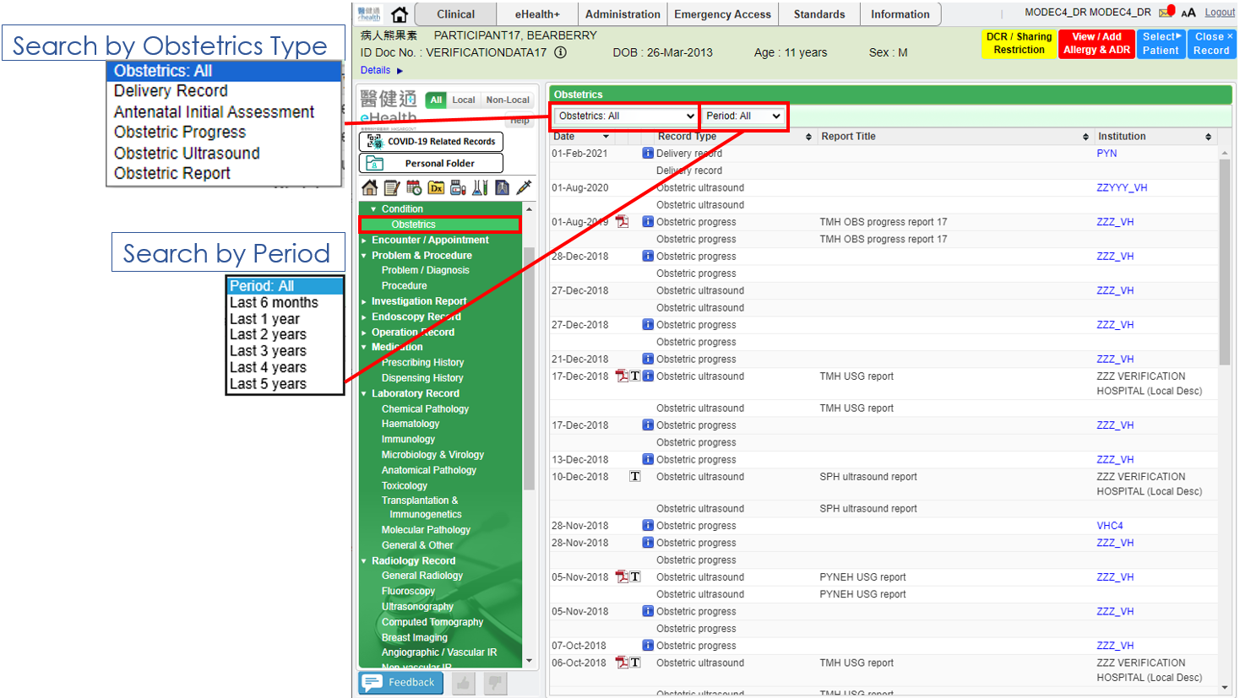

**Notations:**

|  |  |
| --- | --- |
|  | Below **Additional information** will be provided after clicking it:   * Delivery record remark * Antenatal initial assessment remark * Obstetric progress remark * Obstetric ultrasound remark |

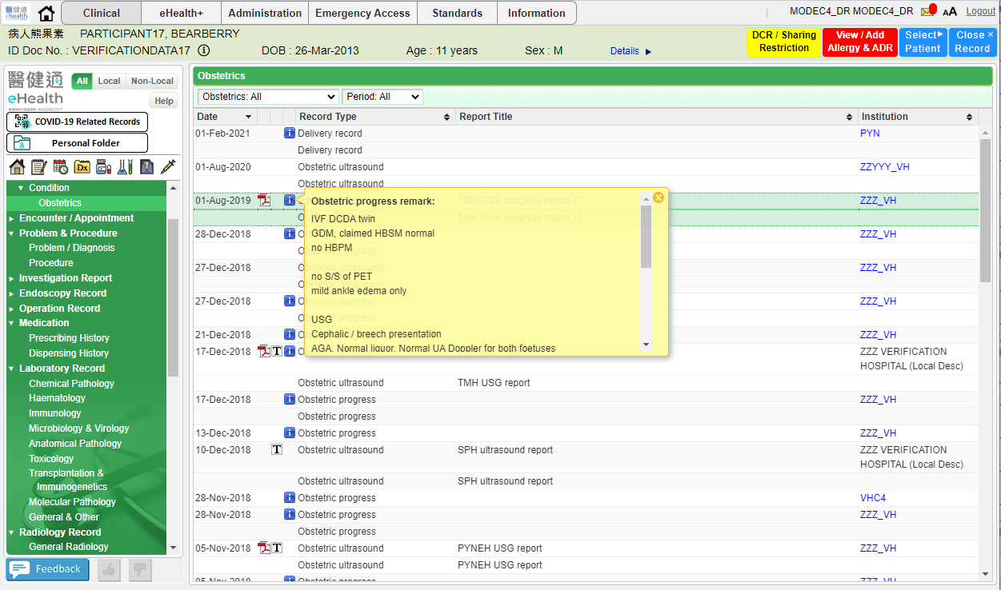

* Five Obstetrics type shows by filtering in Obstetrics Type View, i.e. Delivery Record, Antenatal Initial Assessment, Obstetric Progress, Obstetric Ultrasound, Obstetric Report.

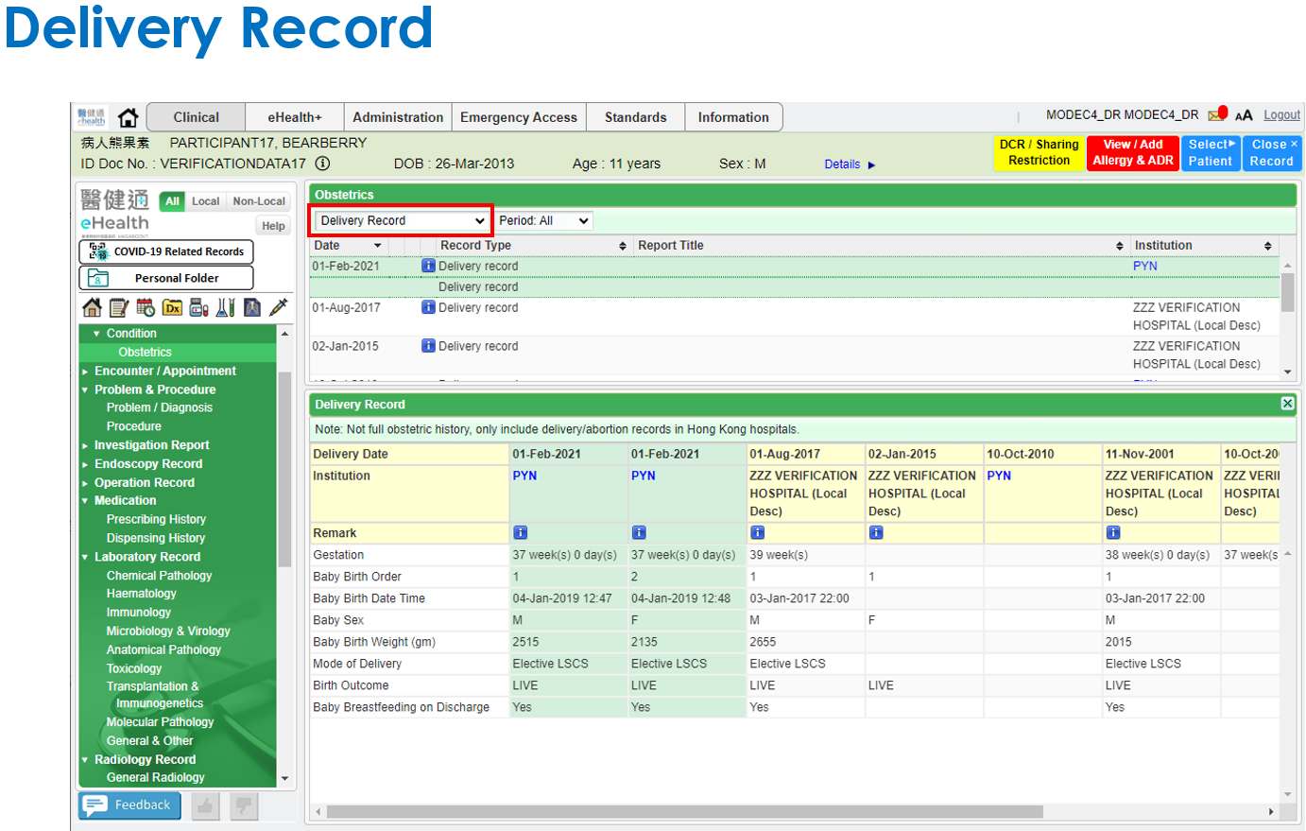

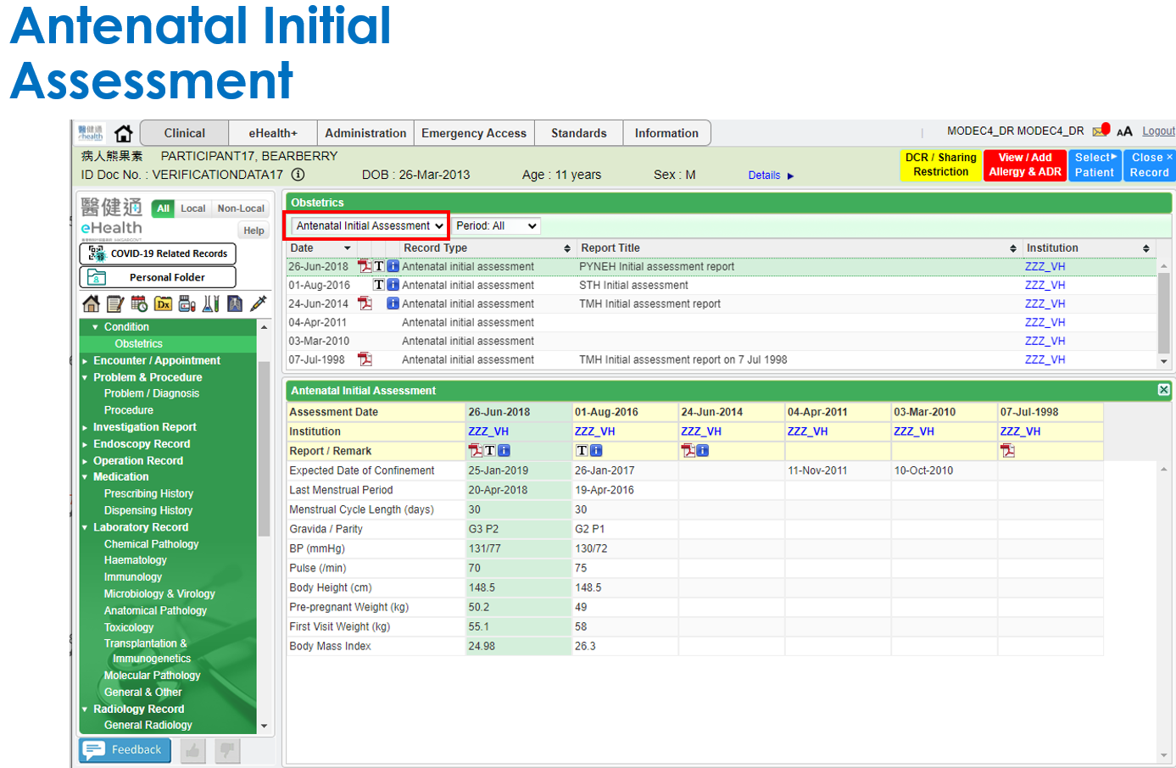

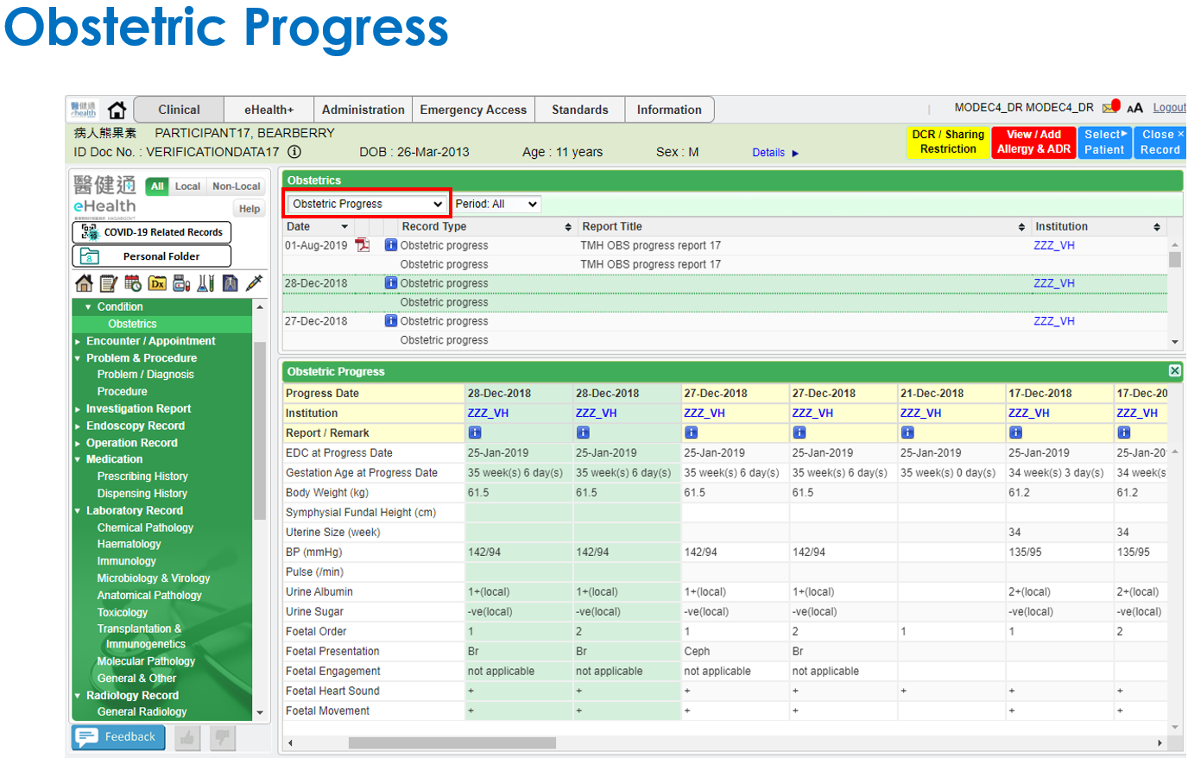

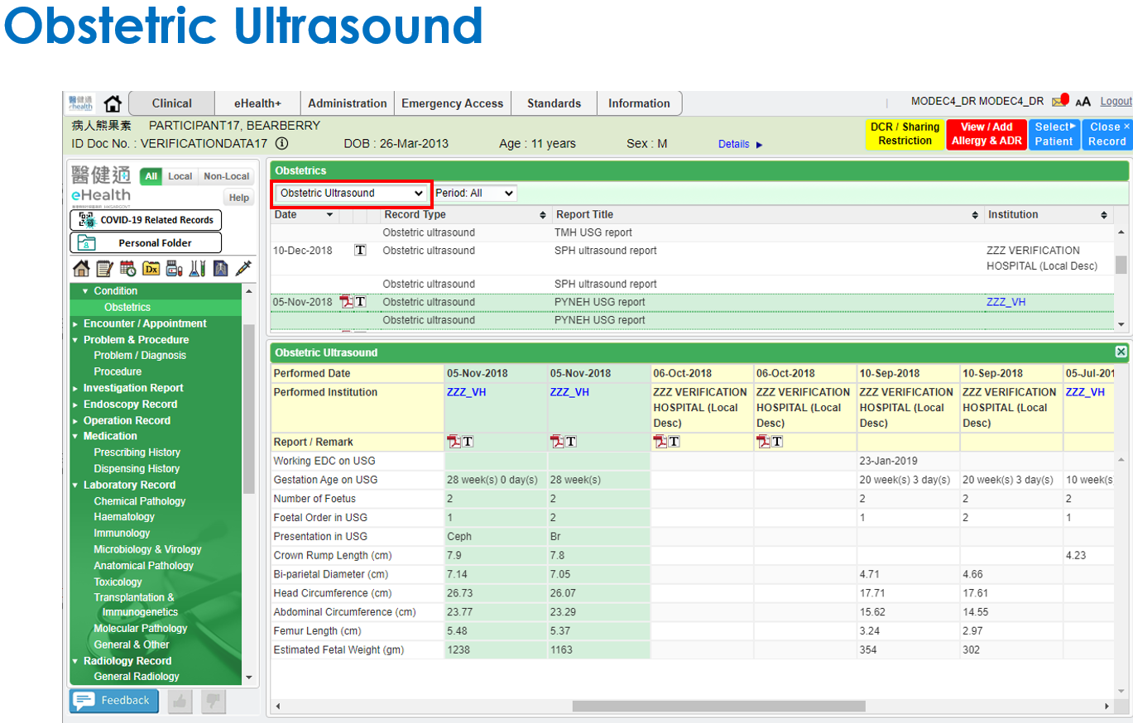

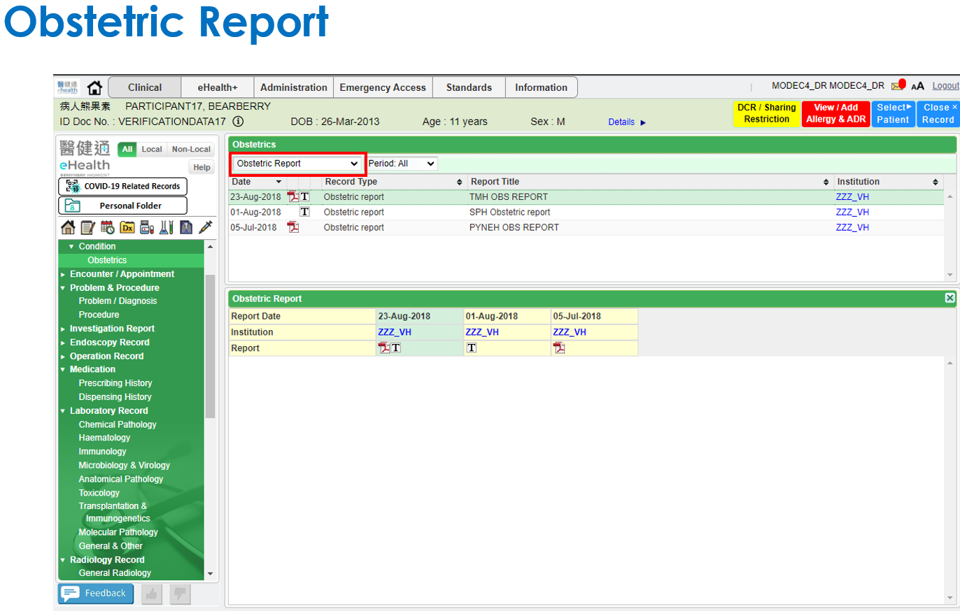

# Appendix – Actual Data Values (Sample)

If the actual values entered are various from the test case, please provide actual values as below.

If the value is not inputted, please use [BLANK] to indicate that empty value is inputted intentionally.

